BWD Report For the Bathing Season 2017
Slovenia

The report gives a general overview of information acquired from the reported data, based on provisions of the Bathing Water Directive. The reporting process is described below, as well as state and trends of bathing water quality in Slovenia.

BWD reporting in the season 2017

In the 2017 bathing season, 47 bathing waters have been reported in Slovenia. For each bathing water, five groups of parameters have been delivered:
Bathing waters of Slovenia in 2017

Total reported 47
Coastal 21
Inland 26

Max season period 78 / 107 days
Coastal 1 Jun to 15 Sep
Inland 15 Jun to 31 Aug

Samples taken 358

Share of bathing waters 98 %
with good or excellent
water quality

Reporting under 2010
Directive 2006/7/EC since
- identification data – including name, location, coastal, inland or transitional type of bathing water and availability to bathers;
- seasonal data – including season start and end, national quality classification in the recent season, potential management measures and changes that are likely to affect the classification of the bathing water;
- monitoring results – disaggregated numerical values of two microbiological parameters – intestinal enterococci and Escherichia coli (also known as E. coli), recorded at each water sample taken;
- abnormal situation periods – periods of an event or combination of events impacting on bathing water quality, during which monitoring calendar may be suspended; reporting is optional;
- short-term pollution periods – measurable events of microbiological contamination; reporting is optional.

The authorities of Slovenia report data according to the new BWD (2006/7/EC) since the season 2010.

Altogether, 47 bathing waters have been reported – 0.2% of all bathing waters in Europe. No bathing waters have been newly reported in the recent season. 45% of bathing waters in Slovenia are of coastal type; the other 55% are inland. 358 samples were taken at bathing waters throughout the season – 8 per bathing water on average.

The bathing season period was from 1 June to 15 September for coastal bathing waters, i.e. 107 days altogether. Inland bathing season period was from 15 June to 31 August, i.e. 78 days.

Detailed information on bathing waters is available from national portal at http://www.mop.gov.si/si/delovna_podrocja/voda/kopalne_vode/.

Assessment methodology

During the bathing season, water samples are taken and analysed for two bacteria, Escherichia coli and intestinal enterococci which may indicate the presence of pollution, usually originating in sewage, livestock waste, bird faeces etc. The results of the analysis are used to assess the quality of the bathing waters concerned and to provide information to the public on the quality of water in the bathing sites concerned.

The monitoring requirements under the Directive are:
- taking a pre-season sample (taken shortly before the start of the bathing season) ;
- a minimum of four samples per season;
- a minimum of one sample per month.

If these rules are satisfied, the bathing water is categorised as 'sampling frequency satisfied'. If not all monitoring requirements are fulfilled the bathing water is categorised as 'not enough samples'. 100.0% of bathing waters met the described monitoring requirements set by the Directive, while the rest did not satisfy monitoring requirements for different reasons: being new; having changed environmental conditions that might affect water quality classification; closed; not monitored due to legal issues, physical inaccessibility to the site etc. Table 1 shows the statistics of bathing waters according to monitoring requirements.

Table 1: Bathing waters in 2017 according to compliance with BWD monitoring provisions
 | Count | Share of total [%]
BWs with sampling frequency satisfied (and are not new, are not subject to changes or were not closed in 2017)  These bathing waters have been monitored according to provisions and have complete dataset from the last assessment period. They have been quality-classified (excellent, good, sufficient, poor). | 47 | 100.0%
BWs with sampling frequency not satisfied (and are not new, are not subject to changes or were not closed in 2017)  These bathing waters exist throughout the last assessment period but have not been monitored throughout the period according to provisions for various individual reasons. They may be quality-classified if there is an adequate volume of samples available for credible classification. | 0 | 0.0%
BWs that are new, subject to changes or closed in 2017  These bathing waters do not have complete dataset for the last assessment period because they are new, have been subject to changes (that are likely to affect the classification of the bathing water) or have been closed. They cannot be quality-classified. | 0 | 0.0%
Total number of bathing waters in 2017 | 47 | 100%

Bathing waters where sampling frequency was not satisfied can still be quality assessed if at least four samples per season (three samples if the season does not exceed eight weeks or the region is subject to special geographical constraints) are available and equally distributed throughout the season. Assessment of bathing water quality is possible when the bathing water sample dataset is available for four consecutive seasons. Bathing waters are accordingly classified to one of the bathing water quality classes (excellent, good, sufficient, or poor).

The classification is based on pre-defined percentile values for microbiological enumerations, limiting the classes given in Annex I of the Directive. The Directive defines different limit values for coastal and inland waters.

Quality assessment is not possible for all bathing waters. In these cases, they are instead classified as either:
• not enough samples;
• new;
• changes;
• closed.

Bathing water quality

The results of the bathing water quality in Slovenia throughout the past period are presented in Figure 1 (for coastal bathing waters) and Figure 2 (for inland bathing waters). The previous reports are available on the European Commission's bathing water quality website and the European Environment Agency's bathing water website.

Coastal bathing waters

In Slovenia, all existing coastal bathing waters met excellent water quality standards in 2017. See Appendix 1 for numeric data.

Figure 1: Coastal bathing water quality trend in Slovenia. Note: the “At least sufficient” class also includes bathing waters of “Excellent” quality class, the sum of shares is therefore not 100%.

Inland bathing waters

All existing inland bathing waters were of at least sufficient water quality in 2017. See Appendix 1 for numeric data.

Figure 2: Inland bathing water quality trend in Slovenia. Note: the “At least sufficient” class also includes bathing waters of “Excellent” quality class, the sum of shares is therefore not 100%.

Information regarding management and other issues

Management of bathing waters in Slovenia included publishing monitoring calendar before the season start, organising press conference, monitoring bathing waters throughout the season, assessing quality according to standards of public health institute, assessing overall quality after the season end, informing public online and on site as well as in press, giving advices for safe and healthy bathing to public.

In the bathing season 2017, one temporary closure – health risk warning was issued, at the bathing site of Vila Park Hotel. In order to ensure adequate bathing water quality, regular monitoring of the conditions in the area of bathing waters, adequate drainage and cleaning of municipal waste water and also measures that regulate the ban on fertilization at coastal land, determined by regulations in the field of water protection, are ensured. Regular monitoring of the quality of bathing water showed extremely high measured bacterial values on 1st August 2017. On the basis of this finding appropriate management measures were implemented and information to the public was carried out.

The public was informed about the pollution of the bathing water and the prohibition of bathing on the beach of Vila Park Hotel via websites of the competent institutions (National Institute for public health; Ministry of the environment and spatial planning of Republic of Slovenia, Slovenian Environment Agency) and via the press. The manager of the site closed the bathing water and blocked the access. The bathers were also informed about the prohibition by lifeguards and security guards. A multi-language on-sight sign, a visual sign and a red flag - indicating that this bathing site is temporary closed for bathing - were also fixed.

With field inspection, the source of pollution was found. The pollution occurred due to a breakdown of a sewer pipe and consequent leakage of municipal waste water. The municipal waste water was melted into the terrain and then into the meteor shower, which ends in the immediate vicinity of the Vila Park Hotel. The repair of the damage was carried out and was completed on 4th August 2017 in the afternoon, followed by physical cleaning and rinsing of the meteor channel. Four illegal connections of the domestic faecal sewerage to the public sewage system were also detected and removed.

At the time of the ban, the quality of the water was followed daily on the beach of Hotel Vila Park, on the meteor shower and on two adjacent bathing sites. On both adjacent bathing sites, where daily microbiological quality control was also carried out, bathing water was always appropriate. On the corresponding results of two consecutive samples of water on the beach of Vila Park Hotel, on 7th August 2017 the prohibition was abolished. After the end of the ban, the quality of bathing water was monitored daily, until the end of August.

The information on pollution remediation and abolishment of prohibition was published on the websites of the mentioned competent institutions. Press was also informed and the notifications were fixed at the bathing site.

Bathing water quality assessment presentation in online viewers

The European bathing water legislation focuses on sound management of bathing waters, greater public participation and improved information dissemination. More on the bathing and other water legislation can be found on the European Commission's website: http://ec.europa.eu/environment/water/index_en.htm.

The bathing water section of the Water Information System for Europe (WISE) which is accessible at the EEA bathing water website (http://www.eea.europa.eu/themes/water/interactive/bathing/state-of-bathing-waters) allows users to view the bathing water quality at more than 21 000 coastal and inland sites across Europe. The WISE bathing water quality data viewer combines text and graphical visualisation, providing a quick overview of the bathing water's locations and achieved quality. Having access to bathing water information, citizens are encouraged to make full use of it and participate with their comments.

Appendix 1: Results of bathing water quality in Slovenia from 2014 to 2017

Table 2: Bathing waters in the season 2017 according to quality
 |  | Total  number  of  bathing  waters | Excellent quality |  | At least  sufficient  quality |  | Poor quality |  | Quality  classification  not possible: not  enough samples  /new bathing  waters/bathing  waters subject to changes/closed
 |  | Total  number  of  bathing  waters | Count | % | Count | % | Count | % | Count | %
Coastal | 2014 | 21 | 21 | 100.0 | 21 | 100.0 | 0 | 0.0 | 0 | 0.0
Coastal | 2015 | 21 | 21 | 100.0 | 21 | 100.0 | 0 | 0.0 | 0 | 0.0
Coastal | 2016 | 21 | 21 | 100.0 | 21 | 100.0 | 0 | 0.0 | 0 | 0.0
Coastal | 2017 | 21 | 21 | 100.0 | 21 | 100.0 | 0 | 0.0 | 0 | 0.0
Inland | 2014 | 26 | 11 | 42.3 | 26 | 100.0 | 0 | 0.0 | 0 | 0.0
Inland | 2015 | 26 | 12 | 46.2 | 26 | 100.0 | 0 | 0.0 | 0 | 0.0
Inland | 2016 | 26 | 14 | 53.8 | 26 | 100.0 | 0 | 0.0 | 0 | 0.0
Inland | 2017 | 26 | 14 | 53.8 | 26 | 100.0 | 0 | 0.0 | 0 | 0.0
Total | 2014 | 47 | 32 | 68.1 | 47 | 100.0 | 0 | 0.0 | 0 | 0.0
Total | 2015 | 47 | 33 | 70.2 | 47 | 100.0 | 0 | 0.0 | 0 | 0.0
Total | 2016 | 47 | 35 | 74.5 | 47 | 100.0 | 0 | 0.0 | 0 | 0.0
Total | 2017 | 47 | 35 | 74.5 | 47 | 100.0 | 0 | 0.0 | 0 | 0.0
Note: the class “At least sufficient” also includes bathing waters which are of excellent quality, the sum of shares is therefore not 100%.

Appendix 2: Bathing water quality map

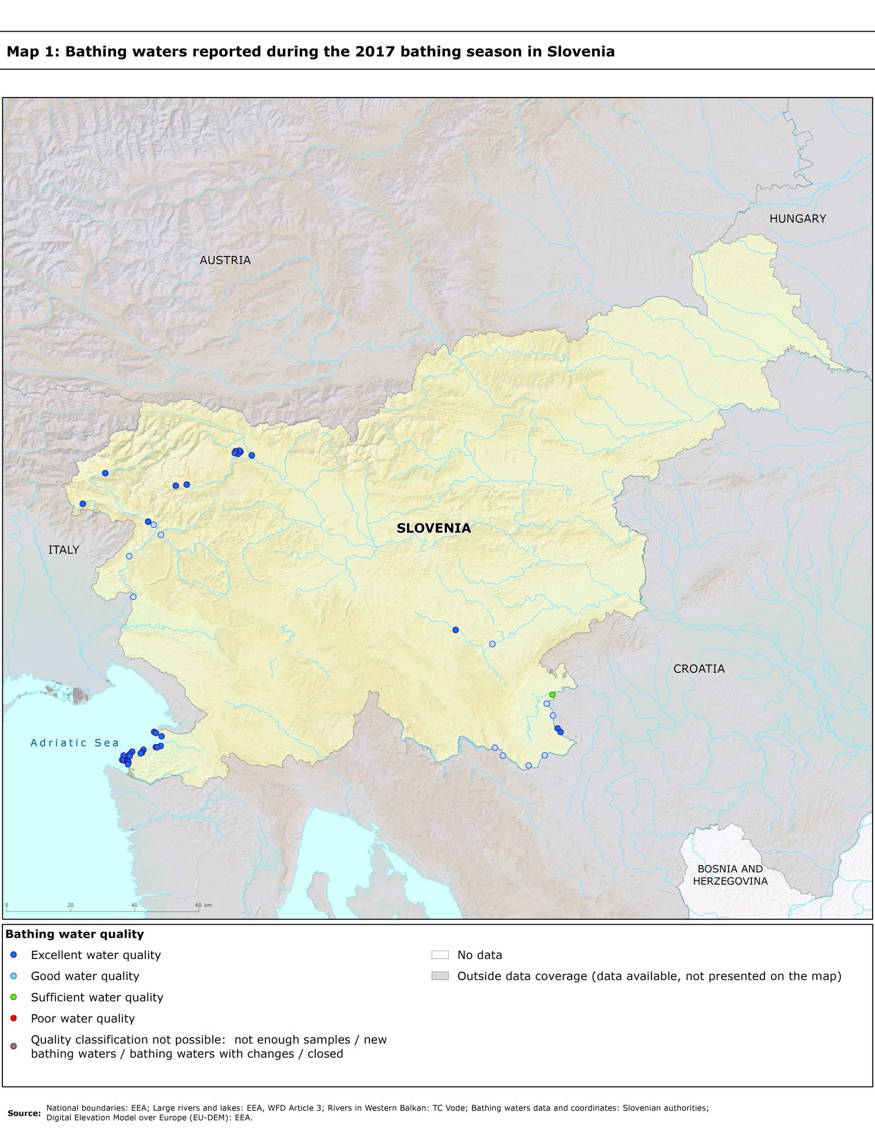

Directive BWD 2006/7/EC, available at http://eur-lex.europa.eu/LexUriServ/LexUriServ.do?uri=OJ:L:2006:064:0037:0051:EN:PDF
See the BWD Data Dictionary for detailed explanations: http://dd.eionet.europa.eu/datasets/3294#tables
The methodology used by the EC and the EEA is described here, while results of assessment by national authorities may differ in individual cases.
A pre-season sample is taken into a sum of samples per season.
Three samples are sufficient if the season does not exceed eight weeks or the region is subject to special geographical constraints.
If, for any reason, it is not possible to take the sample at the scheduled date, a delay of four extra days is allowed. Thus, the interval between two samples should not exceed 31 + 4 days.
Not enough samples have been provided throughout the last assessment period (the last four bathing seasons or, when applicable, the period specified in Article 4.2 or 4.4).
Classification not yet possible because bathing water is newly identified and a complete set of samples is not yet available.
Classification is not yet possible after changes that are likely to affect the classification of the bathing water.
Bathing water is closed temporarily or throughout the bathing season.
http://ec.europa.eu/environment/water/water-bathing/index_en.html
http://www.eea.europa.eu/themes/water/status-and-monitoring/state-of-bathing-water

