BWD Report For the Bathing Season 2017
Portugal

The report gives a general overview of information acquired from the reported data, based on provisions of the Bathing Water Directive. The reporting process is described below, as well as state and trends of bathing water quality in Portugal.

BWD reporting in the season 2017

In the 2017 bathing season, 603 bathing waters have been reported in Portugal. For each bathing water, five groups of parameters have been delivered:
Bathing waters of Portugal in 2017

Total reported 603
Coastal 480
Inland 123

Max season period 135 / 154 days
Coastal 1 May to 15 Oct
Inland 13 May to 30 Sep

Samples taken 3801

Share of bathing waters 95 %
with good or excellent
water quality

Reporting under 2011
Directive 2006/7/EC since
- identification data – including name, location, coastal, inland or transitional type of bathing water and availability to bathers;
- seasonal data – including season start and end, national quality classification in the recent season, potential management measures and changes that are likely to affect the classification of the bathing water;
- monitoring results – disaggregated numerical values of two microbiological parameters – intestinal enterococci and Escherichia coli (also known as E. coli), recorded at each water sample taken;
- abnormal situation periods – periods of an event or combination of events impacting on bathing water quality, during which monitoring calendar may be suspended; reporting is optional;
- short-term pollution periods – measurable events of microbiological contamination; reporting is optional.

The authorities of Portugal report data according to the new BWD (2006/7/EC) since the season 2011.

Altogether, 603 bathing waters have been reported – 2.8% of all bathing waters in Europe. 24 bathing waters have been newly reported in the recent season. 80% of bathing waters in Portugal are of coastal type; the other 20% are inland. 3801 samples were taken at bathing waters throughout the season – 6 per bathing water on average.

The maximum bathing season period was from 1 May to 15 October for coastal bathing waters, i.e. 154 days altogether. Maximum inland bathing season period was from 13 May to 30 September, i.e. 135 days. Season duration varies depending on the bathing water.

Detailed information on bathing waters is available from national portal at http://www.apambiente.pt/index.php?ref=19&subref=906.

Assessment methodology

During the bathing season, water samples are taken and analysed for two bacteria, Escherichia coli and intestinal enterococci which may indicate the presence of pollution, usually originating in sewage, livestock waste, bird faeces etc. The results of the analysis are used to assess the quality of the bathing waters concerned and to provide information to the public on the quality of water in the bathing sites concerned.

The monitoring requirements under the Directive are:
- taking a pre-season sample (taken shortly before the start of the bathing season) ;
- a minimum of four samples per season;
- a minimum of one sample per month.

If these rules are satisfied, the bathing water is categorised as 'sampling frequency satisfied'. If not all monitoring requirements are fulfilled the bathing water is categorised as 'not enough samples'. 97.5% of bathing waters met the described monitoring requirements set by the Directive, while the rest did not satisfy monitoring requirements for different reasons: being new; having changed environmental conditions that might affect water quality classification; closed; not monitored due to legal issues, physical inaccessibility to the site etc. Table 1 shows the statistics of bathing waters according to monitoring requirements.

Table 1: Bathing waters in 2017 according to compliance with BWD monitoring provisions
 | Count | Share of total [%]
BWs with sampling frequency satisfied (and are not new, are not subject to changes or were not closed in 2017)  These bathing waters have been monitored according to provisions and have complete dataset from the last assessment period. They have been quality-classified (excellent, good, sufficient, poor). | 588 | 97.5%
BWs with sampling frequency not satisfied (and are not new, are not subject to changes or were not closed in 2017)  These bathing waters exist throughout the last assessment period but have not been monitored throughout the period according to provisions for various individual reasons. They may be quality-classified if there is an adequate volume of samples available for credible classification. | 0 | 0.0%
BWs that are new, subject to changes or closed in 2017  These bathing waters do not have complete dataset for the last assessment period because they are new, have been subject to changes (that are likely to affect the classification of the bathing water) or have been closed. They cannot be quality-classified. | 15 | 2.5%
Total number of bathing waters in 2017 | 603 | 100%

Bathing waters where sampling frequency was not satisfied can still be quality assessed if at least four samples per season (three samples if the season does not exceed eight weeks or the region is subject to special geographical constraints) are available and equally distributed throughout the season. Assessment of bathing water quality is possible when the bathing water sample dataset is available for four consecutive seasons. Bathing waters are accordingly classified to one of the bathing water quality classes (excellent, good, sufficient, or poor).

The classification is based on pre-defined percentile values for microbiological enumerations, limiting the classes given in Annex I of the Directive. The Directive defines different limit values for coastal and inland waters.

Quality assessment is not possible for all bathing waters. In these cases, they are instead classified as either:
• not enough samples;
• new;
• changes;
• closed.

Bathing water quality

The results of the bathing water quality in Portugal throughout the past period are presented in Figure 1 (for coastal bathing waters) and Figure 2 (for inland bathing waters). The previous reports are available on the European Commission's bathing water quality website and the European Environment Agency's bathing water website.

Coastal bathing waters

In Portugal, 97.7% of all existing coastal bathing waters met at least sufficient water quality standards in 2017. See Appendix 1 for numeric data.

Figure 1: Coastal bathing water quality trend in Portugal. Note: the “At least sufficient” class also includes bathing waters of “Excellent” quality class, the sum of shares is therefore not 100%.

Inland bathing waters

92.7% of all existing inland bathing waters were of at least sufficient water quality in 2017. See Appendix 1 for numeric data.

Figure 2: Inland bathing water quality trend in Portugal. Note: the “At least sufficient” class also includes bathing waters of “Excellent” quality class, the sum of shares is therefore not 100%.

Information regarding management and other issues

Management of bathing waters include information to the public, locally and online, the reinforcement of monitoring and surveillance actions, the control and improvement of urban wastewater systems, the public awareness, among other measures. Bathing waters with classification of sufficient or poor are subjected to reinforcement of monitoring. These measures were carried out by different institutions in articulation, at national, regional and local level, involving Environment, Health and Maritime authorities, as well as municipalities, taking into account bathing water profiles, but also specific conditions of the bathing season.

In 2017, there were repair works at the bathing water “Praia da Ribeira das Galinhas”. This bathing place was identified in the bathing season 2015 for the first time. The access to the water was assured by groyne/pier and a slipway, both made of reinforced concrete. During 2016 the slipway showed signs of erosion and since then, as a precautionary measure and for safety reasons, access to the slipway was restricted using a chain and visual sign for information. During winter and spring season of 2017, the ocean damages in this structure increased, exposing the steel reinforcing bars which posed a great danger to bathers. Repairs were necessary, but they were only possible to start on 12th of June. To carry out the works heavy machinery was needed. Public was informed about the works and the access to the area was prevented for safety reasons. Consequently bathing activities were not allowed and therefore it was not possible to start the bathing season as expected on 17th of June. Sampling was consequently also not allowed. Repair works lasted around 2 weeks and on 30th of June, after work was completed, access for bathers was allowed. To ensure bathing water quality before access to the water was granted, a sample was taken before that - on 28th of June.

Concerning monitoring calendar at this bathing site, five samples were planned to be taken, but due to the explained abnormal situation that occurred previously to bathing season and the necessity for repairs, it was not possible to collect the first sample. Nevertheless, it was possible to collect four samples, one of them before the bathing activities were allowed. All samples obtained results compatible with “excellent” quality. These results are compatible with the results from previous bathing seasons. Under these circumstances it was considered that abnormal situation could be applicable to this bathing water, justifying the suspension of the monitoring calendar between 14th and 28th of June, and allowing quality class classification of bathing water “Praia da Ribeira das Galinhas” as “excellent”.

Information on the internet – Portugal Mainland and Autonomous Regions

The online provision of information on bathing water is performed by the Portuguese Environment Agency (APA), integrated in two websites: the APA official website and the site linked with the database. Besides, and concerning Autonomous Regions of Azores and Madeira, there are regional websites.

The APA official website located at http://www.apambiente.pt/index.php?ref=19&subref=906 presents information about the bathing water classification in previous years, as well as the European Environment Agency reports and a link to the information concerning the previous bathing season.

Also available are sites of the Autonomous Region of Azores (http://www.azores.gov.pt/Gra/SRMCT-MAR/menus/secundario/Zonas+Balneares/) and Autonomous Region of Madeira (http://dramb.gov-madeira.pt/berilio/berwpag0.listctn?pCtn=103).

Bathing water quality assessment presentation in online viewers

The European bathing water legislation focuses on sound management of bathing waters, greater public participation and improved information dissemination. More on the bathing and other water legislation can be found on the European Commission's website: http://ec.europa.eu/environment/water/index_en.htm.

The bathing water section of the Water Information System for Europe (WISE) which is accessible at the EEA bathing water website (http://www.eea.europa.eu/themes/water/interactive/bathing/state-of-bathing-waters) allows users to view the bathing water quality at more than 21 000 coastal and inland sites across Europe. The WISE bathing water quality data viewer combines text and graphical visualisation, providing a quick overview of the bathing water's locations and achieved quality. Having access to bathing water information, citizens are encouraged to make full use of it and participate with their comments.

Appendix 1: Results of bathing water quality in Portugal from 2014 to 2017

Table 2: Bathing waters in the season 2017 according to quality
 |  | Total  number  of  bathing  waters | Excellent quality |  | At least  sufficient  quality |  | Poor quality |  | Quality  classification  not possible: not  enough samples  /new bathing  waters/bathing  waters subject to changes/closed
 |  | Total  number  of  bathing  waters | Count | % | Count | % | Count | % | Count | %
Coastal | 2014 | 452 | 395 | 87.4 | 435 | 96.2 | 5 | 1.1 | 12 | 2.7
Coastal | 2015 | 460 | 412 | 89.6 | 450 | 97.8 | 3 | 0.7 | 7 | 1.5
Coastal | 2016 | 464 | 413 | 89.0 | 454 | 97.8 | 4 | 0.9 | 6 | 1.3
Coastal | 2017 | 480 | 435 | 90.6 | 469 | 97.7 | 3 | 0.6 | 8 | 1.7
Inland | 2014 | 106 | 56 | 52.8 | 91 | 85.8 | 1 | 0.9 | 14 | 13.2
Inland | 2015 | 109 | 69 | 63.3 | 98 | 89.9 | 0 | 0.0 | 11 | 10.1
Inland | 2016 | 115 | 80 | 69.6 | 108 | 93.9 | 0 | 0.0 | 7 | 6.1
Inland | 2017 | 123 | 94 | 76.4 | 114 | 92.7 | 2 | 1.6 | 7 | 5.7
Total | 2014 | 558 | 451 | 80.8 | 526 | 94.3 | 6 | 1.1 | 26 | 4.7
Total | 2015 | 569 | 481 | 84.5 | 548 | 96.3 | 3 | 0.5 | 18 | 3.2
Total | 2016 | 579 | 493 | 85.1 | 562 | 97.1 | 4 | 0.7 | 13 | 2.2
Total | 2017 | 603 | 529 | 87.7 | 583 | 96.7 | 5 | 0.8 | 15 | 2.5
Note: the class “At least sufficient” also includes bathing waters which are of excellent quality, the sum of shares is therefore not 100%.

Appendix 2: Bathing water quality map

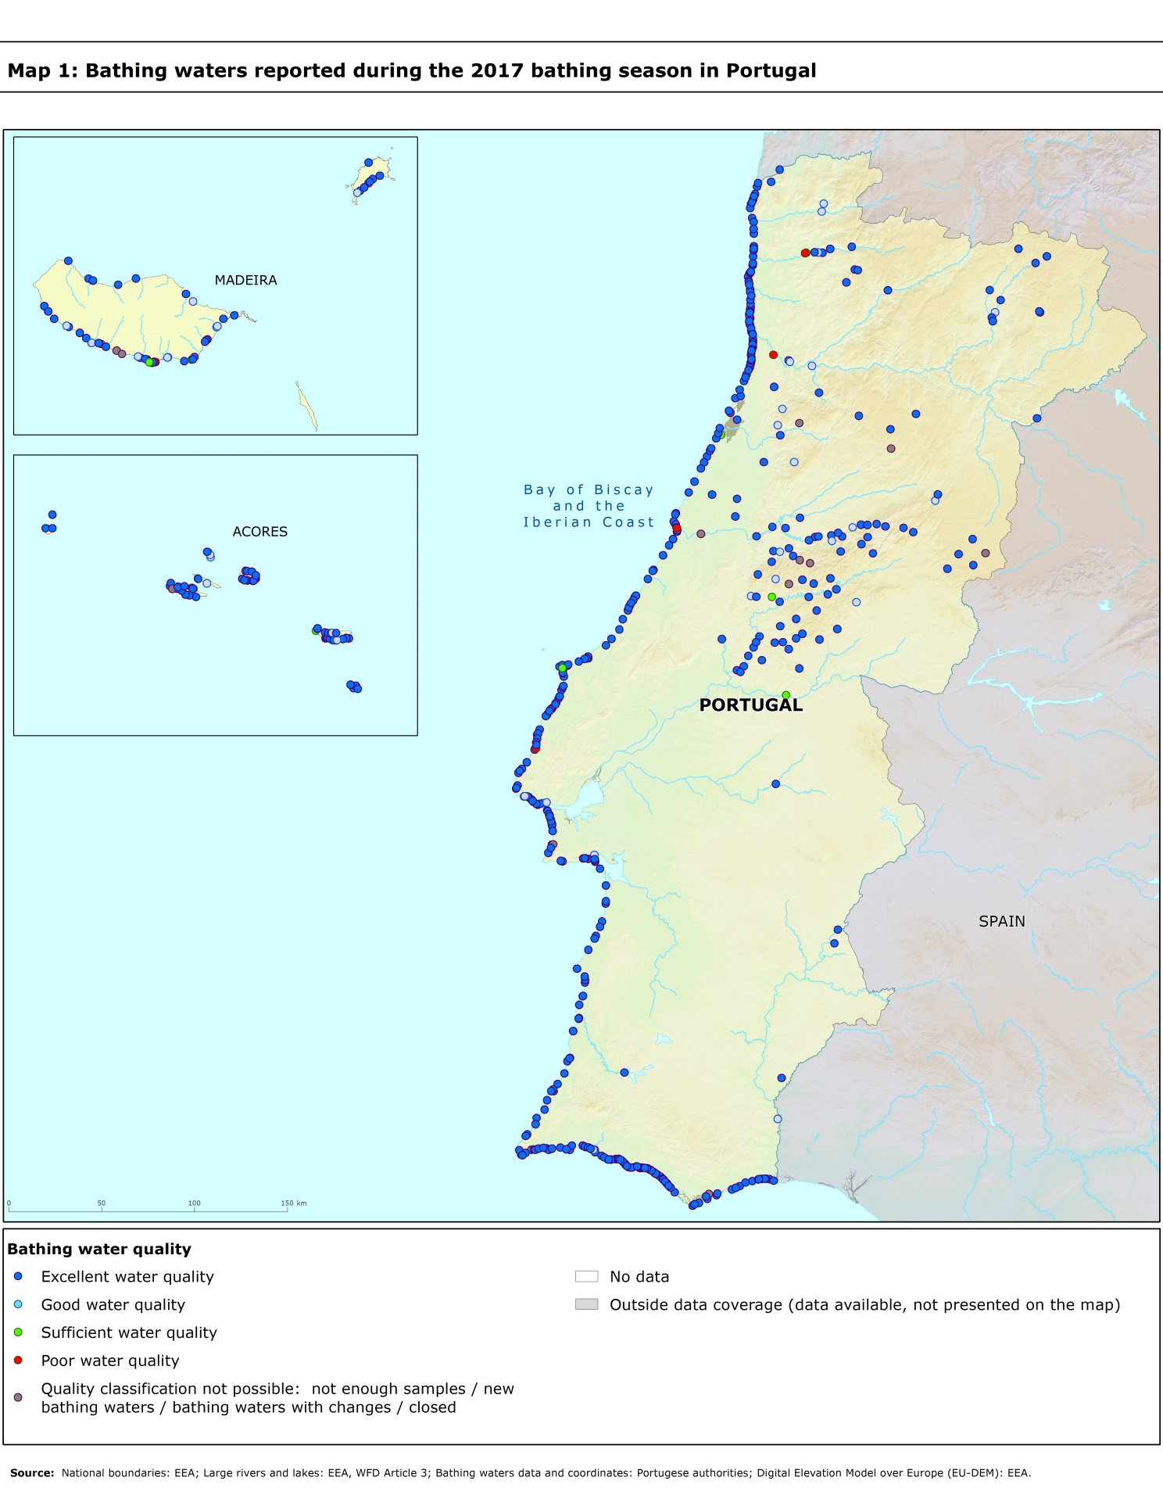

Directive BWD 2006/7/EC, available at http://eur-lex.europa.eu/LexUriServ/LexUriServ.do?uri=OJ:L:2006:064:0037:0051:EN:PDF
See the BWD Data Dictionary for detailed explanations: http://dd.eionet.europa.eu/datasets/3294#tables
The methodology used by the EC and the EEA is described here, while results of assessment by national authorities may differ in individual cases.
A pre-season sample is taken into a sum of samples per season.
Three samples are sufficient if the season does not exceed eight weeks or the region is subject to special geographical constraints.
If, for any reason, it is not possible to take the sample at the scheduled date, a delay of four extra days is allowed. Thus, the interval between two samples should not exceed 31 + 4 days.
Not enough samples have been provided throughout the last assessment period (the last four bathing seasons or, when applicable, the period specified in Article 4.2 or 4.4).
Classification not yet possible because bathing water is newly identified and a complete set of samples is not yet available.
Classification is not yet possible after changes that are likely to affect the classification of the bathing water.
Bathing water is closed temporarily or throughout the bathing season.
http://ec.europa.eu/environment/water/water-bathing/index_en.html
http://www.eea.europa.eu/themes/water/status-and-monitoring/state-of-bathing-water

