BWD Report For the Bathing Season 2017
Ireland

The report gives a general overview of information acquired from the reported data, based on provisions of the Bathing Water Directive. The reporting process is described below, as well as state and trends of bathing water quality in Ireland.

BWD reporting in the season 2017

In the 2017 bathing season, 142 bathing waters have been reported in Ireland. For each bathing water, five groups of parameters have been delivered:
Bathing waters of Ireland in 2017

Total reported 142
Coastal 133
Inland 9

Max season period 107 days
1 Jun to 15 Sep

Samples taken 1504

Share of bathing waters 85 %
with good or excellent
water quality

Reporting under 2011
Directive 2006/7/EC since
- identification data – including name, location, coastal, inland or transitional type of bathing water and availability to bathers;
- seasonal data – including season start and end, national quality classification in the recent season, potential management measures and changes that are likely to affect the classification of the bathing water;
- monitoring results – disaggregated numerical values of two microbiological parameters – intestinal enterococci and Escherichia coli (also known as E. coli), recorded at each water sample taken;
- abnormal situation periods – periods of an event or combination of events impacting on bathing water quality, during which monitoring calendar may be suspended; reporting is optional;
- short-term pollution periods – measurable events of microbiological contamination; reporting is optional.

The authorities of Ireland report data according to the new BWD (2006/7/EC) since the season 2011.

Altogether, 142 bathing waters have been reported – 0.7% of all bathing waters in Europe. Two bathing waters have been newly reported in the recent season. 94% of bathing waters in Ireland are of coastal type; the other 6% are inland. 1504 samples were taken at bathing waters throughout the season – 11 per bathing water on average.

The bathing season period was from 1 June to 15 September, i.e. 107 days altogether.

Detailed information on bathing waters is available from national portal at https://www.beaches.ie/.

Assessment methodology

During the bathing season, water samples are taken and analysed for two bacteria, Escherichia coli and intestinal enterococci which may indicate the presence of pollution, usually originating in sewage, livestock waste, bird faeces etc. The results of the analysis are used to assess the quality of the bathing waters concerned and to provide information to the public on the quality of water in the bathing sites concerned.

The monitoring requirements under the Directive are:
- taking a pre-season sample (taken shortly before the start of the bathing season) ;
- a minimum of four samples per season;
- a minimum of one sample per month.

If these rules are satisfied, the bathing water is categorised as 'sampling frequency satisfied'. If not all monitoring requirements are fulfilled the bathing water is categorised as 'not enough samples'. 97.9% of bathing waters met the described monitoring requirements set by the Directive, while the rest did not satisfy monitoring requirements for different reasons: being new; having changed environmental conditions that might affect water quality classification; closed; not monitored due to legal issues, physical inaccessibility to the site etc. Table 1 shows the statistics of bathing waters according to monitoring requirements.

Table 1: Bathing waters in 2017 according to compliance with BWD monitoring provisions
 | Count | Share of total [%]
BWs with sampling frequency satisfied (and are not new, are not subject to changes or were not closed in 2017)  These bathing waters have been monitored according to provisions and have complete dataset from the last assessment period. They have been quality-classified (excellent, good, sufficient, poor). | 139 | 97.9%
BWs with sampling frequency not satisfied (and are not new, are not subject to changes or were not closed in 2017)  These bathing waters exist throughout the last assessment period but have not been monitored throughout the period according to provisions for various individual reasons. They may be quality-classified if there is an adequate volume of samples available for credible classification. | 0 | 0.0%
BWs that are new, subject to changes or closed in 2017  These bathing waters do not have complete dataset for the last assessment period because they are new, have been subject to changes (that are likely to affect the classification of the bathing water) or have been closed. They cannot be quality-classified. | 3 | 2.1%
Total number of bathing waters in 2017 | 142 | 100%

Bathing waters where sampling frequency was not satisfied can still be quality assessed if at least four samples per season (three samples if the season does not exceed eight weeks or the region is subject to special geographical constraints) are available and equally distributed throughout the season. Assessment of bathing water quality is possible when the bathing water sample dataset is available for four consecutive seasons. Bathing waters are accordingly classified to one of the bathing water quality classes (excellent, good, sufficient, or poor).

The classification is based on pre-defined percentile values for microbiological enumerations, limiting the classes given in Annex I of the Directive. The Directive defines different limit values for coastal and inland waters.

Quality assessment is not possible for all bathing waters. In these cases, they are instead classified as either:
• not enough samples;
• new;
• changes;
• closed.

Bathing water quality

The results of the bathing water quality in Ireland throughout the past period are presented in Figure 1 (for coastal bathing waters) and Figure 2 (for inland bathing waters). The previous reports are available on the European Commission's bathing water quality website and the European Environment Agency's bathing water website.

Coastal bathing waters

In Ireland, 92.5% of all existing coastal bathing waters met at least sufficient water quality standards in 2017. See Appendix 1 for numeric data.

Figure 1: Coastal bathing water quality trend in Ireland. Note: the “At least sufficient” class also includes bathing waters of “Excellent” quality class, the sum of shares is therefore not 100%.

Inland bathing waters

All existing inland bathing waters were of at least sufficient water quality in 2017. See Appendix 1 for numeric data.

Figure 2: Inland bathing water quality trend in Ireland. Note: the “At least sufficient” class also includes bathing waters of “Excellent” quality class, the sum of shares is therefore not 100%.

Information regarding management and other issues

Bathing water in Ireland is sampled and analysed by local authorities and electronically reported via the Monitoring Data System and via the Bathing Water Information System (BWIS) to the Environmental Protection Agency (EPA), where formal assessment is done. Data are held in a dedicated Information management system. Among others, incidents and short-term pollution (STP) warnings are submitted electronically and this information is conveyed to the public via the new national bathing water information website http://www.beaches.ie (replaced Splash website) and the Agency’s bathing water Twitter account (the public is informed about the start date, nature and duration of incidents, and can view bathing water warnings/restriction notices applied at the beaches; when a certain incident ends, it is removed from beaches.ie, and a notification through the Agency’s bathing water Twitter account is given). The choice of signage (Advisory or Prohibition) is based on advice from the Health Service Executive (HSE) based on single sample acceptance criteria determined by the Agency and HSE.

2017 saw more incidents reported than in 2016: 163 compared to 81 (in 2015, however, there were 147 incidents). Many of Ireland’s bathing waters are known to be markedly affected by weather events, particularly by heavy rainfall. This is most evident in the waters close to urban areas such as greater Dublin and other major cities where the influence of wastewater discharges can be a crucial factor in the assessment of overall quality. Rural bathing waters tend to be affected more by diffuse pollution from agricultural sources and from rivers. Of the 163 reported incidents in 2017, 113 were precautionary STP notifications - prior warnings, issued as a precaution measure for the possible elevation of bacterial levels in the relevant bathing waters in response to forecasted heavy rainfall or emergency discharge from waste water treatment plant/network. However, following analysis of scheduled or investigative samples, the majority of the prior warning STP incidents reported showed no evidence of pollution and were deemed invalid incidents.

The beaches.ie website (https://www.beaches.ie) is a new bathing water information website, launched in June 2017. As already mentioned, it shares the latest information on water quality, tides and other information for beaches and lakes around Ireland. The water quality results and notification of incidents throughout the summer are provided by local authorities via an EPA online information system which automatically updates beaches.ie. The design of beaches.ie site takes into account beach users’ requirements identified from the 2016 EPA Beach Information Survey and the requirements for a responsive site that will work on both mobile and PC based platforms. The public can also contribute by reporting different issues via certain apps and engaging with beaches.ie with feedback and queries via hello@beaches.ie.

Two new bathing waters, Carne (Co. Wexford) and Seafield, Quilty (Co. Clare), were identified in 2017. Bathing water profiles for the 142 identified bathing waters in Ireland are available to view, download and print (pdf format) also from the www.beaches.ie website.

Following assessment of identified bathing waters in Ireland in 2016, six bathing waters were classed as poor. These bathing waters had bathing restrictions in place for the entire 2017 bathing season. ‘Advice Not to Swim’ notices were placed at four of these bathing waters and there were ‘Bathing Prohibition’ notices at two. 2017 Management Plans for improving the water quality at these bathing waters were provided to the EPA and all were monitored during the 2017 bathing season.

Following assessment of the identified bathing waters in Ireland in 2017, seven bathing waters have been classed as Poor. Of these, five bathing waters (Merrion Strand, Ballyloughane Beach, Clifden Beach, Loughshinny Beach and Portrane the Brook Beach) were poor in the previous season and two bathing waters (Sandymount Strand and Rush, South Beach) are newly classified as poor in 2017. There are different possible sources of pollution: dog walkers and subsequent dog fouling, the presence of gulls and migratory birds, septic tanks, different harbour activities, storm water overflows, pumping station emergency overflows, sewer overflows, domestic wastewater treatment systems that are not functioning correctly etc. The summary update of the issues as reported by relevant local authorities on the measures undertaken in 2017 and future plans to improve the water quality at these bathing waters are available for the public to view on beaches.ie.

Bathing water quality assessment presentation in online viewers

The European bathing water legislation focuses on sound management of bathing waters, greater public participation and improved information dissemination. More on the bathing and other water legislation can be found on the European Commission's website: http://ec.europa.eu/environment/water/index_en.htm.

The bathing water section of the Water Information System for Europe (WISE) which is accessible at the EEA bathing water website (http://www.eea.europa.eu/themes/water/interactive/bathing/state-of-bathing-waters) allows users to view the bathing water quality at more than 21 000 coastal and inland sites across Europe. The WISE bathing water quality data viewer combines text and graphical visualisation, providing a quick overview of the bathing water's locations and achieved quality. Having access to bathing water information, citizens are encouraged to make full use of it and participate with their comments.

Appendix 1: Results of bathing water quality in Ireland from 2014 to 2017

Table 2: Bathing waters in the season 2017 according to quality
 |  | Total  number  of  bathing  waters | Excellent quality |  | At least  sufficient  quality |  | Poor quality |  | Quality  classification  not possible: not  enough samples  /new bathing  waters/bathing  waters subject to changes/closed
 |  | Total  number  of  bathing  waters | Count | % | Count | % | Count | % | Count | %
Coastal | 2014 | 127 | 95 | 74.8 | 120 | 94.5 | 6 | 4.7 | 1 | 0.8
Coastal | 2015 | 128 | 93 | 72.7 | 120 | 93.8 | 6 | 4.7 | 2 | 1.6
Coastal | 2016 | 131 | 94 | 71.8 | 121 | 92.4 | 6 | 4.6 | 4 | 3.1
Coastal | 2017 | 133 | 94 | 70.7 | 123 | 92.5 | 7 | 5.3 | 3 | 2.3
Inland | 2014 | 9 | 8 | 88.9 | 8 | 88.9 | 1 | 11.1 | 0 | 0.0
Inland | 2015 | 9 | 8 | 88.9 | 8 | 88.9 | 0 | 0.0 | 1 | 11.1
Inland | 2016 | 9 | 8 | 88.9 | 9 | 100.0 | 0 | 0.0 | 0 | 0.0
Inland | 2017 | 9 | 8 | 88.9 | 9 | 100.0 | 0 | 0.0 | 0 | 0.0
Total | 2014 | 136 | 103 | 75.7 | 128 | 94.1 | 7 | 5.1 | 1 | 0.7
Total | 2015 | 137 | 101 | 73.7 | 128 | 93.4 | 6 | 4.4 | 3 | 2.2
Total | 2016 | 140 | 102 | 72.9 | 130 | 92.9 | 6 | 4.3 | 4 | 2.9
Total | 2017 | 142 | 102 | 71.8 | 132 | 93.0 | 7 | 4.9 | 3 | 2.1
Note: the class “At least sufficient” also includes bathing waters which are of excellent quality, the sum of shares is therefore not 100%.

Appendix 2: Bathing water quality map

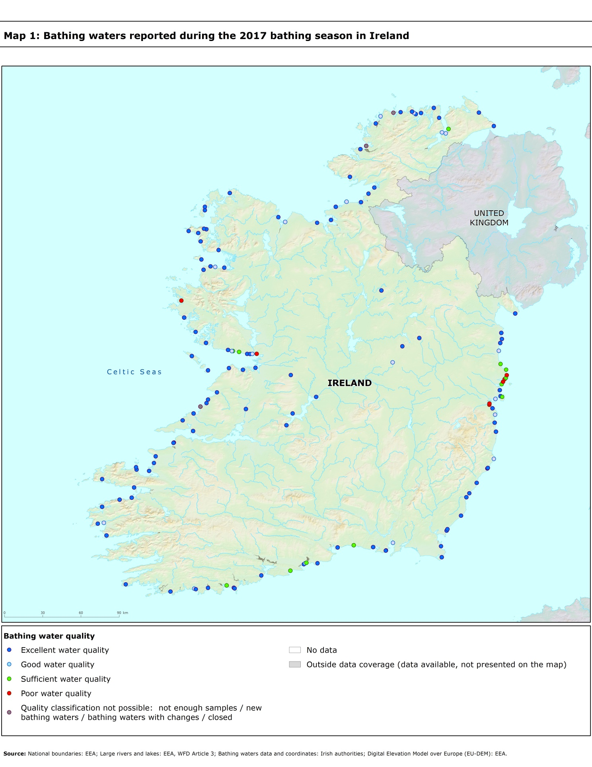

Directive BWD 2006/7/EC, available at http://eur-lex.europa.eu/LexUriServ/LexUriServ.do?uri=OJ:L:2006:064:0037:0051:EN:PDF
See the BWD Data Dictionary for detailed explanations: http://dd.eionet.europa.eu/datasets/3294#tables
The methodology used by the EC and the EEA is described here, while results of assessment by national authorities may differ in individual cases.
A pre-season sample is taken into a sum of samples per season.
Three samples are sufficient if the season does not exceed eight weeks or the region is subject to special geographical constraints.
If, for any reason, it is not possible to take the sample at the scheduled date, a delay of four extra days is allowed. Thus, the interval between two samples should not exceed 31 + 4 days.
Not enough samples have been provided throughout the last assessment period (the last four bathing seasons or, when applicable, the period specified in Article 4.2 or 4.4).
Classification not yet possible because bathing water is newly identified and a complete set of samples is not yet available.
Classification is not yet possible after changes that are likely to affect the classification of the bathing water.
Bathing water is closed temporarily or throughout the bathing season.
http://ec.europa.eu/environment/water/water-bathing/index_en.html
http://www.eea.europa.eu/themes/water/status-and-monitoring/state-of-bathing-water

