BWD Report For the Bathing Season 2017
Croatia

The report gives a general overview of information acquired from the reported data, based on provisions of the Bathing Water Directive. The reporting process is described below, as well as state and trends of bathing water quality in Croatia.

BWD reporting in the season 2017

In the 2017 bathing season, 976 bathing waters have been reported in Croatia. For each bathing water, five groups of parameters have been delivered:
Bathing waters of Croatia in 2017

Total reported 976
Coastal 949
Inland 27

Max season period 107 / 127 days
Coastal 1 Jun to 5 Oct
Inland 1 Jun to 15 Sep

Samples taken 9712

Share of bathing waters 95 %
with good or excellent
water quality

Reporting under 2009
Directive 2006/7/EC since
- identification data – including name, location, coastal, inland or transitional type of bathing water and availability to bathers;
- seasonal data – including season start and end, national quality classification in the recent season, potential management measures and changes that are likely to affect the classification of the bathing water;
- monitoring results – disaggregated numerical values of two microbiological parameters – intestinal enterococci and Escherichia coli (also known as E. coli), recorded at each water sample taken;
- abnormal situation periods – periods of an event or combination of events impacting on bathing water quality, during which monitoring calendar may be suspended; reporting is optional;
- short-term pollution periods – measurable events of microbiological contamination; reporting is optional.

The authorities of Croatia report data according to the new BWD (2006/7/EC) since the season 2009.

Altogether, 976 bathing waters have been reported – 4.5% of all bathing waters in Europe. 26 bathing waters have been newly reported in the recent season. 97% of bathing waters in Croatia are of coastal type; the other 3% are inland. 9712 samples were taken at bathing waters throughout the season – 10 per bathing water on average.

The maximum bathing season period was from 1 June to 5 October for coastal bathing waters, i.e. 127 days altogether. Maximum inland bathing season period was from 1 June to 15 September, i.e. 107 days. Season duration varies for inland bathing waters.

Detailed information on bathing waters is available from national portal at http://www.haop.hr/.

Assessment methodology

During the bathing season, water samples are taken and analysed for two bacteria, Escherichia coli and intestinal enterococci which may indicate the presence of pollution, usually originating in sewage, livestock waste, bird faeces etc. The results of the analysis are used to assess the quality of the bathing waters concerned and to provide information to the public on the quality of water in the bathing sites concerned.

The monitoring requirements under the Directive are:
- taking a pre-season sample (taken shortly before the start of the bathing season) ;
- a minimum of four samples per season;
- a minimum of one sample per month.

If these rules are satisfied, the bathing water is categorised as 'sampling frequency satisfied'. If not all monitoring requirements are fulfilled the bathing water is categorised as 'not enough samples'. 93.8% of bathing waters met the described monitoring requirements set by the Directive, while the rest did not satisfy monitoring requirements for different reasons: being new; having changed environmental conditions that might affect water quality classification; closed; not monitored due to legal issues, physical inaccessibility to the site etc. Table 1 shows the statistics of bathing waters according to monitoring requirements.

Table 1: Bathing waters in 2017 according to compliance with BWD monitoring provisions
 | Count | Share of total [%]
BWs with sampling frequency satisfied (and are not new, are not subject to changes or were not closed in 2017)  These bathing waters have been monitored according to provisions and have complete dataset from the last assessment period. They have been quality-classified (excellent, good, sufficient, poor). | 915 | 93.8%
BWs with sampling frequency not satisfied (and are not new, are not subject to changes or were not closed in 2017)  These bathing waters exist throughout the last assessment period but have not been monitored throughout the period according to provisions for various individual reasons. They may be quality-classified if there is an adequate volume of samples available for credible classification. | 17 | 1.7%
BWs that are new, subject to changes or closed in 2017  These bathing waters do not have complete dataset for the last assessment period because they are new, have been subject to changes (that are likely to affect the classification of the bathing water) or have been closed. They cannot be quality-classified. | 44 | 4.5%
Total number of bathing waters in 2017 | 976 | 100%

Bathing waters where sampling frequency was not satisfied can still be quality assessed if at least four samples per season (three samples if the season does not exceed eight weeks or the region is subject to special geographical constraints) are available and equally distributed throughout the season. Assessment of bathing water quality is possible when the bathing water sample dataset is available for four consecutive seasons. Bathing waters are accordingly classified to one of the bathing water quality classes (excellent, good, sufficient, or poor).

The classification is based on pre-defined percentile values for microbiological enumerations, limiting the classes given in Annex I of the Directive. The Directive defines different limit values for coastal and inland waters.

Quality assessment is not possible for all bathing waters. In these cases, they are instead classified as either:
• not enough samples;
• new;
• changes;
• closed.

Bathing water quality

The results of the bathing water quality in Croatia throughout the past period are presented in Figure 1 (for coastal bathing waters) and Figure 2 (for inland bathing waters). The previous reports are available on the European Commission's bathing water quality website and the European Environment Agency's bathing water website.

Coastal bathing waters

In Croatia, 96.9% of all existing coastal bathing waters met at least sufficient water quality standards in 2017. See Appendix 1 for numeric data.

Figure 1: Coastal bathing water quality trend in Croatia. Note: the “At least sufficient” class also includes bathing waters of “Excellent” quality class, the sum of shares is therefore not 100%.

Inland bathing waters

29.6% of all existing inland bathing waters were of at least sufficient water quality in 2017. See Appendix 1 for numeric data.

Figure 2: Inland bathing water quality trend in Croatia. Note: the “At least sufficient” class also includes bathing waters of “Excellent” quality class, the sum of shares is therefore not 100%.

Information regarding management and other issues

Bathing water quality monitoring is carried out under Regulation on sea bathing water quality (OG 73/08) and Regulation on bathing water quality (OG 51/14). Regulations set out standards for bathing water quality at the coastal, transitional and inland beaches, establish the limit values for microbiological parameters and other characteristics of the coastal, transitional and inland waters. In order to achieve the required standards, management measures for the bathing waters were established.

The bathing season in Croatia is the period from 1 June until 15 September, unless due to weather conditions and local customs, the representative body of the county issues a decision on the bathing season lasting for a longer period of time. Monitoring of bathing water quality at sea beaches lasts from 15 May until 30 September. Before each bathing season the county is obliged to determine sampling points. Before the start of each bathing season the authorised person is obliged to determine monitoring calendar consistent with the relevant administrative body in the county. Bathing water monitoring has to start no later than four days from the date specified in the calendar.

Based on bathing water quality monitoring results individual, annual and final assessments are made. The individual assessment is determined after each analysis carried out during the bathing season, according to the limit values for the microbiological parameters referred by the Regulation. The annual assessment is determined after the end of the bathing season, based on a set of data on bathing water quality for that particular bathing season, according to the limit values for the microbiological parameters referred by the Regulation.

The final assessment is determined after the end of the last bathing season and the three preceding bathing seasons, according to the limit values for the microbiological parameters referred by the Regulation, based on a data set of at least 28 samples for each sampling point.

Monitoring data are available for public on the internet, where users are allowed to make comments and suggestion considering each bathing water, to propose new sampling points, to get additional information of the beaches and even to report on possible sudden and short term pollutions. For inland bathing waters monitoring data are available on http://baltazar.izor.hr/plazekpub/kakvoca. A constant increase in the number of web visitors was detected on this web site in the past few years, which shows, that web users have recognised this page as a valuable source of information. Monitoring data for coastal bathing waters are available on http://baltazar.izor.hr/plazepub/kakvoca_detalji10. Most of the suggestions for new sampling points referred to the most interesting beaches, while most of the comments from public were reports of pollutions, and there were also some praises. The application for mobile phones which makes uses of modern technologies, such as GPS was produced in 2012. Bathing water profiles are available for majority of bathing waters as well and the major parts of profiles are publicly available from 2014.

In 2003 the project “Coastal Cities Water Pollution Control Project” has started. It includes 47 subprojects for construction and modernization of sewage systems and waste water treatment along the coast of the mainland and islands. The project has a long-term character. By the end of the third phase it is envisaged that all Croatian coast and islands will be adequately covered with sewage systems and waste water treatment plants. The situation has been already improved in the area around the cities of Rijeka, Opatija, Zadar and Šibenik which is evident from the bathing water quality trends.

Implementation of Marine strategy framework directive MSFD is also on-going and it is expected that by the 2018 Monitoring program for ongoing assessment regarding all eleven MSFD descriptors will be fully implemented.

Additional details on coastal bathing water monitoring, management measures, short-term pollutions and general implementation of the BWD are included in an extensive report produced by the national authorities (in Croatian; http://www.mzoip.hr/doc/izvjesce_o_kakvoci_mora_za_kupanje_u_rh_2017.pdf).

For the 2017 bathing season, 20 short-term pollutions (on 19 distinct bathing waters) have been reported in Croatia. Five of these short-time pollutions were reported at an inland bathing area (at lake Jarun, which includes 16 sampling points), while other short-time pollutions were recorded among the coastal bathing waters. Some among the (potential) reasons for short-time pollutions were for instance heavy precipitations and consequent inlet of storm water from land into the sea; overflow of fecal water from septic tanks; etc. There were no abnormal situations in 2017.

Bathing water quality assessment presentation in online viewers

The European bathing water legislation focuses on sound management of bathing waters, greater public participation and improved information dissemination. More on the bathing and other water legislation can be found on the European Commission's website: http://ec.europa.eu/environment/water/index_en.htm.

The bathing water section of the Water Information System for Europe (WISE) which is accessible at the EEA bathing water website (http://www.eea.europa.eu/themes/water/interactive/bathing/state-of-bathing-waters) allows users to view the bathing water quality at more than 21 000 coastal and inland sites across Europe. The WISE bathing water quality data viewer combines text and graphical visualisation, providing a quick overview of the bathing water's locations and achieved quality. Having access to bathing water information, citizens are encouraged to make full use of it and participate with their comments.

Appendix 1: Results of bathing water quality in Croatia from 2014 to 2017

Table 2: Bathing waters in the season 2017 according to quality
 |  | Total  number  of  bathing  waters | Excellent quality |  | At least  sufficient  quality |  | Poor quality |  | Quality  classification  not possible: not  enough samples  /new bathing  waters/bathing  waters subject to changes/closed
 |  | Total  number  of  bathing  waters | Count | % | Count | % | Count | % | Count | %
Coastal | 2014 | 918 | 885 | 96.4 | 905 | 98.6 | 3 | 0.3 | 10 | 1.1
Coastal | 2015 | 908 | 877 | 96.6 | 896 | 98.7 | 0 | 0.0 | 12 | 1.3
Coastal | 2016 | 922 | 889 | 96.4 | 905 | 98.2 | 0 | 0.0 | 17 | 1.8
Coastal | 2017 | 949 | 909 | 95.8 | 920 | 96.9 | 0 | 0.0 | 29 | 3.1
Inland | 2014 | 27 | 3 | 11.1 | 7 | 25.9 | 0 | 0.0 | 20 | 74.1
Inland | 2015 | 27 | 4 | 14.8 | 7 | 25.9 | 0 | 0.0 | 20 | 74.1
Inland | 2016 | 27 | 4 | 14.8 | 8 | 29.6 | 0 | 0.0 | 19 | 70.4
Inland | 2017 | 27 | 4 | 14.8 | 8 | 29.6 | 0 | 0.0 | 19 | 70.4
Total | 2014 | 945 | 888 | 94.0 | 912 | 96.5 | 3 | 0.3 | 30 | 3.2
Total | 2015 | 935 | 881 | 94.2 | 903 | 96.6 | 0 | 0.0 | 32 | 3.4
Total | 2016 | 949 | 893 | 94.1 | 913 | 96.2 | 0 | 0.0 | 36 | 3.8
Total | 2017 | 976 | 913 | 93.5 | 928 | 95.1 | 0 | 0.0 | 48 | 4.9
Note: the class “At least sufficient” also includes bathing waters which are of excellent quality, the sum of shares is therefore not 100%.

Appendix 2: Bathing water quality map

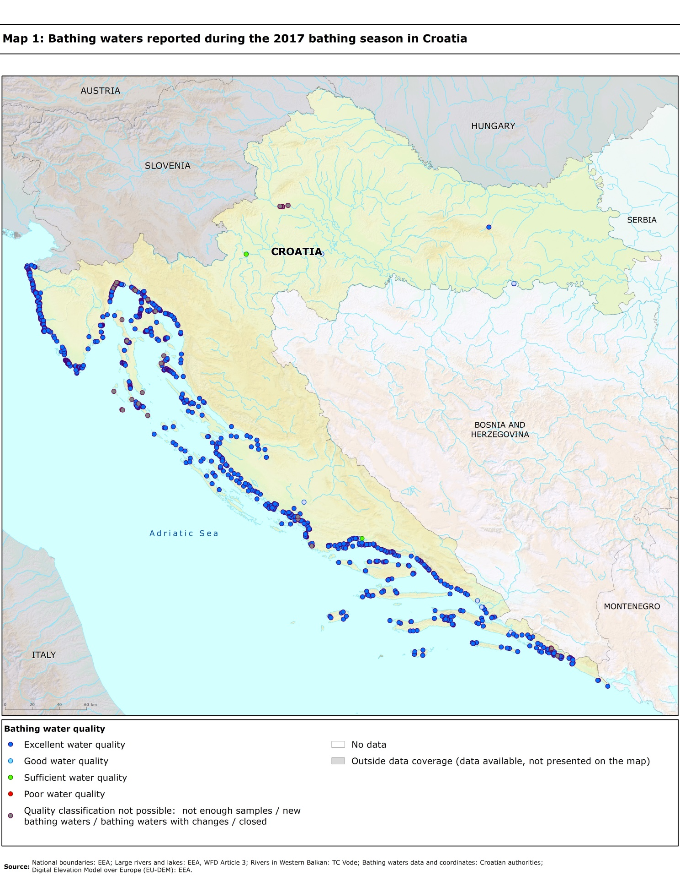

Directive BWD 2006/7/EC, available at http://eur-lex.europa.eu/LexUriServ/LexUriServ.do?uri=OJ:L:2006:064:0037:0051:EN:PDF
See the BWD Data Dictionary for detailed explanations: http://dd.eionet.europa.eu/datasets/3294#tables
The methodology used by the EC and the EEA is described here, while results of assessment by national authorities may differ in individual cases.
A pre-season sample is taken into a sum of samples per season.
Three samples are sufficient if the season does not exceed eight weeks or the region is subject to special geographical constraints.
If, for any reason, it is not possible to take the sample at the scheduled date, a delay of four extra days is allowed. Thus, the interval between two samples should not exceed 31 + 4 days.
Not enough samples have been provided throughout the last assessment period (the last four bathing seasons or, when applicable, the period specified in Article 4.2 or 4.4).
Classification not yet possible because bathing water is newly identified and a complete set of samples is not yet available.
Classification is not yet possible after changes that are likely to affect the classification of the bathing water.
Bathing water is closed temporarily or throughout the bathing season.
http://ec.europa.eu/environment/water/water-bathing/index_en.html
http://www.eea.europa.eu/themes/water/status-and-monitoring/state-of-bathing-water

