BWD Report For the Bathing Season 2017
Greece

The report gives a general overview of information acquired from the reported data, based on provisions of the Bathing Water Directive. The reporting process is described below, as well as state and trends of bathing water quality in Greece.

BWD reporting in the season 2017

In the 2017 bathing season, 1598 bathing waters have been reported in Greece. For each bathing water, five groups of parameters have been delivered:
Bathing waters of Greece in 2017

Total reported 1598
Coastal 1595
Inland 3

Max season period 153 days
1 Jun to 31 Oct

Samples taken 9699

Share of bathing waters 97 %
with good or excellent
water quality

Reporting under 2010
Directive 2006/7/EC since
- identification data – including name, location, coastal, inland or transitional type of bathing water and availability to bathers;
- seasonal data – including season start and end, national quality classification in the recent season, potential management measures and changes that are likely to affect the classification of the bathing water;
- monitoring results – disaggregated numerical values of two microbiological parameters – intestinal enterococci and Escherichia coli (also known as E. coli), recorded at each water sample taken;
- abnormal situation periods – periods of an event or combination of events impacting on bathing water quality, during which monitoring calendar may be suspended; reporting is optional;
- short-term pollution periods – measurable events of microbiological contamination; reporting is optional.

The authorities of Greece report data according to the new BWD (2006/7/EC) since the season 2010.

Altogether, 1598 bathing waters have been reported – 7.3% of all bathing waters in Europe. 58 bathing waters have been newly reported in the recent season. All bathing waters in Greece are of coastal type. 9699 samples were taken at bathing waters throughout the season – 6 per bathing water on average.

The bathing season period was from 1 June to 31 October, i.e. 153 days altogether.

Detailed information on bathing waters is available from national portal at http://www.bathingwaterprofiles.gr/.

Assessment methodology

During the bathing season, water samples are taken and analysed for two bacteria, Escherichia coli and intestinal enterococci which may indicate the presence of pollution, usually originating in sewage, livestock waste, bird faeces etc. The results of the analysis are used to assess the quality of the bathing waters concerned and to provide information to the public on the quality of water in the bathing sites concerned.

The monitoring requirements under the Directive are:
- taking a pre-season sample (taken shortly before the start of the bathing season) ;
- a minimum of four samples per season;
- a minimum of one sample per month.

If these rules are satisfied, the bathing water is categorised as 'sampling frequency satisfied'. If not all monitoring requirements are fulfilled the bathing water is categorised as 'not enough samples'. 89.9% of bathing waters met the described monitoring requirements set by the Directive, while the rest did not satisfy monitoring requirements for different reasons: being new; having changed environmental conditions that might affect water quality classification; closed; not monitored due to legal issues, physical inaccessibility to the site etc. Table 1 shows the statistics of bathing waters according to monitoring requirements.

Table 1: Bathing waters in 2017 according to compliance with BWD monitoring provisions
 | Count | Share of total [%]
BWs with sampling frequency satisfied (and are not new, are not subject to changes or were not closed in 2017)  These bathing waters have been monitored according to provisions and have complete dataset from the last assessment period. They have been quality-classified (excellent, good, sufficient, poor). | 1437 | 89.9%
BWs with sampling frequency not satisfied (and are not new, are not subject to changes or were not closed in 2017)  These bathing waters exist throughout the last assessment period but have not been monitored throughout the period according to provisions for various individual reasons. They may be quality-classified if there is an adequate volume of samples available for credible classification. | 108 | 6.8%
BWs that are new, subject to changes or closed in 2017  These bathing waters do not have complete dataset for the last assessment period because they are new, have been subject to changes (that are likely to affect the classification of the bathing water) or have been closed. They cannot be quality-classified. | 53 | 3.3%
Total number of bathing waters in 2017 | 1598 | 100%

Bathing waters where sampling frequency was not satisfied can still be quality assessed if at least four samples per season (three samples if the season does not exceed eight weeks or the region is subject to special geographical constraints) are available and equally distributed throughout the season. Assessment of bathing water quality is possible when the bathing water sample dataset is available for four consecutive seasons. Bathing waters are accordingly classified to one of the bathing water quality classes (excellent, good, sufficient, or poor).

The classification is based on pre-defined percentile values for microbiological enumerations, limiting the classes given in Annex I of the Directive. The Directive defines different limit values for coastal and inland waters.

Quality assessment is not possible for all bathing waters. In these cases, they are instead classified as either:
• not enough samples;
• new;
• changes;
• closed.

Bathing water quality

The results of the bathing water quality in Greece throughout the past period are presented in Figure 1 (for coastal bathing waters) and Figure 2 (for inland bathing waters). The previous reports are available on the European Commission's bathing water quality website and the European Environment Agency's bathing water website.

Coastal bathing waters

In Greece, 96.7% of all existing coastal bathing waters met at least sufficient water quality standards in 2017. See Appendix 1 for numeric data.

Figure 1: Coastal bathing water quality trend in Greece. Note: the “At least sufficient” class also includes bathing waters of “Excellent” quality class, the sum of shares is therefore not 100%.

Inland bathing waters

66.7% of all existing inland bathing waters were of at least sufficient water quality in 2017. See Appendix 1 for numeric data.

Figure 2: Inland bathing water quality trend in Greece. Note: the “At least sufficient” class also includes bathing waters of “Excellent” quality class, the sum of shares is therefore not 100%.

Information regarding management and other issues

The quality of bathing waters in Greece is systematically monitored since 1988 according to Directive 76/160/EEC "on the quality of bathing waters". Since 2010, the quality of bathing water is monitored in accordance with the new Directive 2006/7/EC "on the management of bathing water quality".

The quality parameters monitored have been selected in accordance with the provisions of Directive 2006/7/EC and are grouped into two categories:
- microbiological (E. coli and intestinal enterococchi),
- visually monitored (tarry residues, glass, plastics, rubber or any other waste).

In the 2017 bathing season, there was abnormal situation from 10 September until 31 October at 11 bathing sites because of pollution due to oil spill from the sinking of a tanker at the region of Inner Saronikos Gulf on 10 September. There was a temporary closure and prohibition against bathing to prevent bathers' exposure to pollution; information was given to public on media and on the site; additional measures were cleaning, observing and additional monitoring of the pollution.

Treatment of waste water

With respect to the implementation of the 91/271/EEC Directive (Urban Waste Water Treatment Directive), a large number of wastewater treatment plants have been constructed or are under construction. The agglomerations with equivalent populations above 10000 discharging in sensitive areas and 15000 located in coastal areas are almost fully served by waste water treatment plants (WWTPs), most of them involving advanced treatment, thus contributing to the improvement of bathing water quality of these areas.

In order to follow the progress on the implementation of the Urban Waste Water Treatment Directive, a national database providing information on the Wastewater Treatment Plants is in operation since 2012 and available to the public though the link http://astikalimata.ypeka.gr/. The database includes general information on population served and treatment provided, environmental permits and operational data of the WWTPs.

Treatment of diffuse sources of pollution

Agriculture is, on the EU level, the largest single source of nitrate pollution through run-off, although households and industries also contribute to some extent. The nitrate pollution problem is addressed within the European Union mainly by the Nitrates Directive (91/676/EEC), regarding nitrate pollution caused by agricultural practices, supplemented by the provisions of the Urban Wastewater Directive (91/271/EC), related to sensitive recipients and the Groundwater Directive (2006/118/EC). In surface waters, particularly lakes and closed gulfs, excessive accumulation of nitrogen as well as phosphorus may lead to eutrophication, with adverse impact, due to proliferation of algae and their byproducts, on fish, oxygen levels and amenity value.

An important provision of the Nitrates Directive is the obligation of Member States to designate the so-called Nitrate Vulnerable Zones (NVZs). According to this requirement, several vulnerable zones, with respect to nitrogen pollution from agricultural run-offs have been identified in Greece (http://www.ypeka.gr/Default.aspx?tabid=250&locale=el-GR&language=en-US) and relevant suitable action programmes have been employed, according to art. 5 of the Directive. The adoption of Good Agricultural Practice Codes, obligatory for all farmers operating in a vulnerable zone, is a key element of these programs.

River Basin Management Plans

The implementation of the WFD (Directive 2000/60/EC) offers the overall framework for the protection of all water bodies against sources of pollution. According to the provisions of article 6 and Annex IV of the WFD, all bodies of water designated as recreational waters including areas designated as bathing waters under the Directive 2006/7/EC are included in the protected areas register and as such all 1540 bathing waters identified under the Bathing Water Directive are part of the protected areas register. Specific information on bathing water protected areas and their relation to identified surface water bodies is included in the River Basin Management Plans and the relevant programme of measures.

Online presentation of data

In Greece, information on bathing water quality is available on the internet through Bathing Water Profiles website (http://www.bathingwaterprofiles.gr). Bathing water data information contains yearly bathing waters quality assessment and the updated bathing profile in web page form and pdf file form available for downloading. Additional information on results of the monitoring program are available after the evaluation of the results, dating back to year 2007 for all bathing seasons. Current bathing water monitoring results are also available to the public through GeoRSS web service.

Bathing water quality assessment presentation in online viewers

The European bathing water legislation focuses on sound management of bathing waters, greater public participation and improved information dissemination. More on the bathing and other water legislation can be found on the European Commission's website: http://ec.europa.eu/environment/water/index_en.htm.

The bathing water section of the Water Information System for Europe (WISE) which is accessible at the EEA bathing water website (http://www.eea.europa.eu/themes/water/interactive/bathing/state-of-bathing-waters) allows users to view the bathing water quality at more than 21 000 coastal and inland sites across Europe. The WISE bathing water quality data viewer combines text and graphical visualisation, providing a quick overview of the bathing water's locations and achieved quality. Having access to bathing water information, citizens are encouraged to make full use of it and participate with their comments.

Appendix 1: Results of bathing water quality in Greece from 2014 to 2017

Table 2: Bathing waters in the season 2017 according to quality
 |  | Total  number  of  bathing  waters | Excellent quality |  | At least  sufficient  quality |  | Poor quality |  | Quality  classification  not possible: not  enough samples  /new bathing  waters/bathing  waters subject to changes/closed
 |  | Total  number  of  bathing  waters | Count | % | Count | % | Count | % | Count | %
Coastal | 2014 | 1538 | 1493 | 97.1 | 1516 | 98.6 | 0 | 0.0 | 22 | 1.4
Coastal | 2015 | 1540 | 1497 | 97.2 | 1506 | 97.8 | 0 | 0.0 | 34 | 2.2
Coastal | 2016 | 1540 | 1495 | 97.1 | 1505 | 97.7 | 0 | 0.0 | 35 | 2.3
Coastal | 2017 | 1595 | 1531 | 96.0 | 1543 | 96.7 | 0 | 0.0 | 52 | 3.3
Inland | 2014 | 2 | 1 | 50.0 | 2 | 100.0 | 0 | 0.0 | 0 | 0.0
Inland | 2015 | 2 | 2 | 100.0 | 2 | 100.0 | 0 | 0.0 | 0 | 0.0
Inland | 2016 | 2 | 1 | 50.0 | 2 | 100.0 | 0 | 0.0 | 0 | 0.0
Inland | 2017 | 3 | 2 | 66.7 | 2 | 66.7 | 0 | 0.0 | 1 | 33.3
Total | 2014 | 1540 | 1494 | 97.0 | 1518 | 98.6 | 0 | 0.0 | 22 | 1.4
Total | 2015 | 1542 | 1499 | 97.2 | 1508 | 97.8 | 0 | 0.0 | 34 | 2.2
Total | 2016 | 1542 | 1496 | 97.0 | 1507 | 97.7 | 0 | 0.0 | 35 | 2.3
Total | 2017 | 1598 | 1533 | 95.9 | 1545 | 96.7 | 0 | 0.0 | 53 | 3.3
Note: the class “At least sufficient” also includes bathing waters which are of excellent quality, the sum of shares is therefore not 100%.

Appendix 2: Bathing water quality map

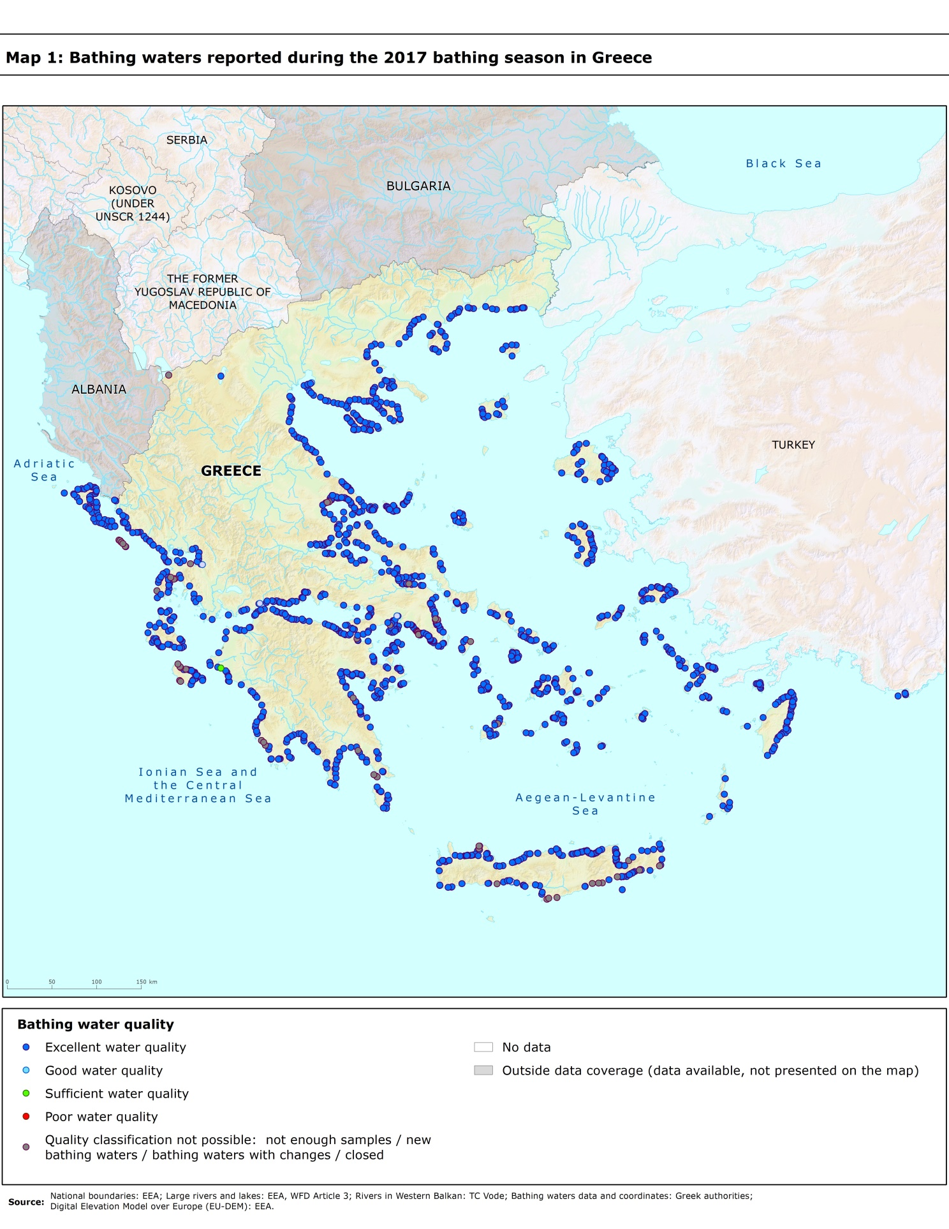

Directive BWD 2006/7/EC, available at http://eur-lex.europa.eu/LexUriServ/LexUriServ.do?uri=OJ:L:2006:064:0037:0051:EN:PDF
See the BWD Data Dictionary for detailed explanations: http://dd.eionet.europa.eu/datasets/3294#tables
The methodology used by the EC and the EEA is described here, while results of assessment by national authorities may differ in individual cases.
A pre-season sample is taken into a sum of samples per season.
Three samples are sufficient if the season does not exceed eight weeks or the region is subject to special geographical constraints.
If, for any reason, it is not possible to take the sample at the scheduled date, a delay of four extra days is allowed. Thus, the interval between two samples should not exceed 31 + 4 days.
Not enough samples have been provided throughout the last assessment period (the last four bathing seasons or, when applicable, the period specified in Article 4.2 or 4.4).
Classification not yet possible because bathing water is newly identified and a complete set of samples is not yet available.
Classification is not yet possible after changes that are likely to affect the classification of the bathing water.
Bathing water is closed temporarily or throughout the bathing season.
http://ec.europa.eu/environment/water/water-bathing/index_en.html
http://www.eea.europa.eu/themes/water/status-and-monitoring/state-of-bathing-water

