BWD Report For the Bathing Season 2017
The Czech Republic

The report gives a general overview of information acquired from the reported data, based on provisions of the Bathing Water Directive. The reporting process is described below, as well as state and trends of bathing water quality in the Czech Republic.

BWD reporting in the season 2017

In the 2017 bathing season, 154 bathing waters have been reported in the Czech Republic. For each bathing water, five groups of parameters have been delivered:
Bathing waters of the Czech Republic in 2017

Total reported 154
Coastal 0
Inland 154

Max season period 102 days
30 May to 15 Sep

Samples taken 847

Share of bathing waters 92 %
with good or excellent
water quality

Reporting under 2012
Directive 2006/7/EC since
- identification data – including name, location, coastal, inland or transitional type of bathing water and availability to bathers;
- seasonal data – including season start and end, national quality classification in the recent season, potential management measures and changes that are likely to affect the classification of the bathing water;
- monitoring results – disaggregated numerical values of two microbiological parameters – intestinal enterococci and Escherichia coli (also known as E. coli), recorded at each water sample taken;
- abnormal situation periods – periods of an event or combination of events impacting on bathing water quality, during which monitoring calendar may be suspended; reporting is optional;
- short-term pollution periods – measurable events of microbiological contamination; reporting is optional.

The authorities of the Czech Republic report data according to the new BWD (2006/7/EC) since the season 2012.

Altogether, 154 bathing waters have been reported – 0.7% of all bathing waters in Europe. No bathing waters have been newly reported in the recent season. All bathing waters in the Czech Republic are inland. 847 samples were taken at bathing waters throughout the season – 6 per bathing water on average.

Maximum bathing season period was from 30 May to 15 September, i.e. 102 days. Season duration varies.

Detailed information on bathing waters is available from national portal at http://www.mzcr.cz/verejne/obsah/koupani-ve-volne-prirode_1071_5.html.

Assessment methodology

During the bathing season, water samples are taken and analysed for two bacteria, Escherichia coli and intestinal enterococci which may indicate the presence of pollution, usually originating in sewage, livestock waste, bird faeces etc. The results of the analysis are used to assess the quality of the bathing waters concerned and to provide information to the public on the quality of water in the bathing sites concerned.

The monitoring requirements under the Directive are:
- taking a pre-season sample (taken shortly before the start of the bathing season) ;
- a minimum of four samples per season;
- a minimum of one sample per month.

If these rules are satisfied, the bathing water is categorised as 'sampling frequency satisfied'. If not all monitoring requirements are fulfilled the bathing water is categorised as 'not enough samples'. 93.5% of bathing waters met the described monitoring requirements set by the Directive, while the rest did not satisfy monitoring requirements for different reasons: being new; having changed environmental conditions that might affect water quality classification; closed; not monitored due to legal issues, physical inaccessibility to the site etc. Table 1 shows the statistics of bathing waters according to monitoring requirements.

Table 1: Bathing waters in 2017 according to compliance with BWD monitoring provisions
 | Count | Share of total [%]
BWs with sampling frequency satisfied (and are not new, are not subject to changes or were not closed in 2017)  These bathing waters have been monitored according to provisions and have complete dataset from the last assessment period. They have been quality-classified (excellent, good, sufficient, poor). | 144 | 93.5%
BWs with sampling frequency not satisfied (and are not new, are not subject to changes or were not closed in 2017)  These bathing waters exist throughout the last assessment period but have not been monitored throughout the period according to provisions for various individual reasons. They may be quality-classified if there is an adequate volume of samples available for credible classification. | 2 | 1.3%
BWs that are new, subject to changes or closed in 2017  These bathing waters do not have complete dataset for the last assessment period because they are new, have been subject to changes (that are likely to affect the classification of the bathing water) or have been closed. They cannot be quality-classified. | 8 | 5.2%
Total number of bathing waters in 2017 | 154 | 100%

Bathing waters where sampling frequency was not satisfied can still be quality assessed if at least four samples per season (three samples if the season does not exceed eight weeks or the region is subject to special geographical constraints) are available and equally distributed throughout the season. Assessment of bathing water quality is possible when the bathing water sample dataset is available for four consecutive seasons. Bathing waters are accordingly classified to one of the bathing water quality classes (excellent, good, sufficient, or poor).

The classification is based on pre-defined percentile values for microbiological enumerations, limiting the classes given in Annex I of the Directive. The Directive defines different limit values for coastal and inland waters.

Quality assessment is not possible for all bathing waters. In these cases, they are instead classified as either:
• not enough samples;
• new;
• changes;
• closed.

Bathing water quality

The results of the bathing water quality in the Czech Republic throughout the past period are presented in Figure 2. The previous reports are available on the European Commission's bathing water quality website and the European Environment Agency's bathing water website.

Coastal bathing waters

There are no coastal bathing waters in The Czech Republic.

Inland bathing waters

92.9% of all existing inland bathing waters were of at least sufficient water quality in 2017. See Appendix 1 for numeric data.

Figure 2: Inland bathing water quality trend in The Czech Republic. Note: the “At least sufficient” class also includes bathing waters of “Excellent” quality class, the sum of shares is therefore not 100%.

Information regarding management and other issues

The Czech Republic held the process of transposition of Directive 2006/7/EC, at the end of the adoption of new national regulations for bathing water. The new regulations have brought many innovations for bathing waters and were first applied in 2012 bathing season.

Central web sites (http://www.mzcr.cz/verejne/obsah/koupani-ve-volne-prirode_1071_5.html; http://www.szu.cz/tema/zivotni-prostredi/koupaliste-a-bazeny, so far only in Czech) were created to keep the public informed about water quality, offering general information focused mostly on potential health risks of bathing in natural water bodies, as well as recommendations on how to reduce the risk. The pages also contain links to web sites of the relevant local Public Health Authorities where information about current quality of water on particular sites is published. Moreover, current information about water quality of every bathing place is displayed at the map server of the Portal of the Public Administration (http://geoportal.gov.cz/koupaci_vody), at the web site Bathing waters (www.koupacivody.cz) and at the maps of several other tourist portals. A set of symbols were designed for simple and clear communication with the public. Information concerning water quality is also published in press (mostly regional) and occasionally in other media (radio and TV stations), and in the summer bathing season, were sent in regular week intervals by the Ministry of Health to the Czech Press Agency a summary of actual water quality report for every bathing water.

Monitoring calendars for all bathing waters were prepared before the bathing season. Bathing water profiles were created in time and information boards were produced and placed in an easily accessible place in the vicinity of each bathing water. Sampling was carried out according to the bathing water monitoring calendar at least once per month. In some cases there was also an increase in the frequency of monitoring, where any exceeding of the national limit for parameters Escherichia coli, Intestinal enterococci or cyanobacteria occurred. Water quality problems are the most frequently related to mass proliferation of cyanobacteria due to the eutrophication of reservoirs and ponds. Measures to reduce eutrophication of waters in the Czech Republic, including bathing waters, are primarily adopted under the programmes implementing the Directive 91/271/EEC concerning urban waste-water treatment and the Directive 91/676/EEC concerning the protection of waters against pollution caused by nitrates from agricultural sources. Selected bathing sites, based on the unsatisfactory water quality results, have been included into the operational water monitoring program. Measures to improve of water quality will also be adopted in the frame of management plans of concerned river basins (Water Framework Directive 2000/60/EC). No outbreak of cercarial dermatitis has occurred during the bathing season 2017.

The most important management measures are:
- Sediment removal
- Intensification/reconstruction/construction of wastewater treatment plant and sewer construction in the immediate vicinity or in the basin of bathing waters clearly affecting the water quality
- Preparation of the study concerning the assessment of current situation, identification of causes of pollution and proposal of measures
- Additional programmes of monitoring
- Action on reservoirs or ponds – aeration, manipulation with fish stock, coagulant dosage to the inflow into the reservoir
- Reconstruction of the reservoir or pond – dam repair, bank alteration
- Reduction of intensity of aquaculture production
- Application of chemicals to reduce the nutrients needed for the development of cyanobacteria and undesirable aquatic flora.

Water quality problems were most frequently related to mass proliferation of cyanobacteria. The WHO recommendation was adopted for the limit value of the “cyanobacteria” indicator, i.e. a three-level water quality assessment with the ban imposed if a visual inspection reveals the presence of water bloom. In the 2017 bathing season there were 14 bathing prohibitions in place (11 due to the presence of cyanobacteria and three due to microbiological pollution).

Two bathing waters were re-opened in 2017 (after no bathing and no sampling in 2016 because of reconstruction).

Bathing water quality assessment presentation in online viewers

The European bathing water legislation focuses on sound management of bathing waters, greater public participation and improved information dissemination. More on the bathing and other water legislation can be found on the European Commission's website: http://ec.europa.eu/environment/water/index_en.htm.

The bathing water section of the Water Information System for Europe (WISE) which is accessible at the EEA bathing water website (http://www.eea.europa.eu/themes/water/interactive/bathing/state-of-bathing-waters) allows users to view the bathing water quality at more than 21 000 coastal and inland sites across Europe. The WISE bathing water quality data viewer combines text and graphical visualisation, providing a quick overview of the bathing water's locations and achieved quality. Having access to bathing water information, citizens are encouraged to make full use of it and participate with their comments.

Appendix 1: Results of bathing water quality in the Czech Republic from 2014 to 2017

Table 2: Bathing waters in the season 2017 according to quality
 |  | Total  number  of  bathing  waters | Excellent quality |  | At least  sufficient  quality |  | Poor quality |  | Quality  classification  not possible: not  enough samples  /new bathing  waters/bathing  waters subject to changes/closed
 |  | Total  number  of  bathing  waters | Count | % | Count | % | Count | % | Count | %
Total | 2014 | 152 | 116 | 76.3 | 139 | 91.4 | 3 | 2.0 | 10 | 6.6
Total | 2015 | 153 | 121 | 79.1 | 142 | 92.8 | 3 | 2.0 | 8 | 5.2
Total | 2016 | 154 | 127 | 82.5 | 142 | 92.2 | 1 | 0.6 | 11 | 7.1
Total | 2017 | 154 | 126 | 81.8 | 143 | 92.9 | 1 | 0.6 | 10 | 6.5
Note: the class “At least sufficient” also includes bathing waters which are of excellent quality, the sum of shares is therefore not 100%.

Appendix 2: Bathing water quality map

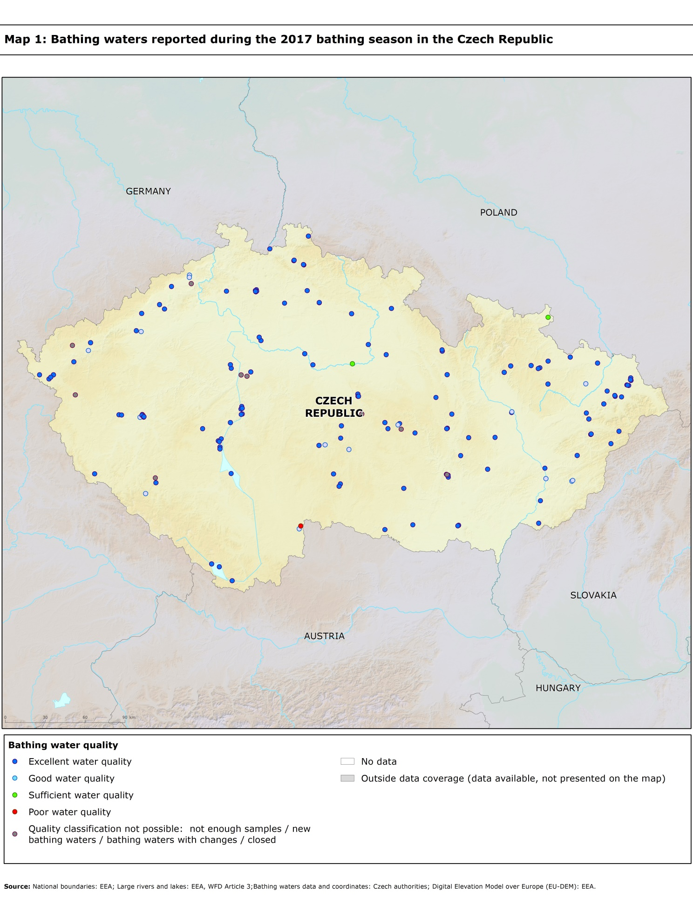

Directive BWD 2006/7/EC, available at http://eur-lex.europa.eu/LexUriServ/LexUriServ.do?uri=OJ:L:2006:064:0037:0051:EN:PDF
See the BWD Data Dictionary for detailed explanations: http://dd.eionet.europa.eu/datasets/3294#tables
The methodology used by the EC and the EEA is described here, while results of assessment by national authorities may differ in individual cases.
A pre-season sample is taken into a sum of samples per season.
Three samples are sufficient if the season does not exceed eight weeks or the region is subject to special geographical constraints.
If, for any reason, it is not possible to take the sample at the scheduled date, a delay of four extra days is allowed. Thus, the interval between two samples should not exceed 31 + 4 days.
Not enough samples have been provided throughout the last assessment period (the last four bathing seasons or, when applicable, the period specified in Article 4.2 or 4.4).
Classification not yet possible because bathing water is newly identified and a complete set of samples is not yet available.
Classification is not yet possible after changes that are likely to affect the classification of the bathing water.
Bathing water is closed temporarily or throughout the bathing season.
http://ec.europa.eu/environment/water/water-bathing/index_en.html
http://www.eea.europa.eu/themes/water/status-and-monitoring/state-of-bathing-water

