BWD Report For the Bathing Season 2017
Bulgaria

The report gives a general overview of information acquired from the reported data, based on provisions of the Bathing Water Directive. The reporting process is described below, as well as state and trends of bathing water quality in Bulgaria.

BWD reporting in the season 2017

In the 2017 bathing season, 95 bathing waters have been reported in Bulgaria. For each bathing water, five groups of parameters have been delivered:
Bathing waters of Bulgaria in 2017

Total reported 95
Coastal 91
Inland 4

Max season period 92 / 139 days
Coastal 15 May to 30 Sep
Inland 1 Jun to 31 Aug

Samples taken 830

Share of bathing waters 92 %
with good or excellent
water quality

Reporting under 2011
Directive 2006/7/EC since
- identification data – including name, location, coastal, inland or transitional type of bathing water and availability to bathers;
- seasonal data – including season start and end, national quality classification in the recent season, potential management measures and changes that are likely to affect the classification of the bathing water;
- monitoring results – disaggregated numerical values of two microbiological parameters – intestinal enterococci and Escherichia coli (also known as E. coli), recorded at each water sample taken;
- abnormal situation periods – periods of an event or combination of events impacting on bathing water quality, during which monitoring calendar may be suspended; reporting is optional;
- short-term pollution periods – measurable events of microbiological contamination; reporting is optional.

The authorities of Bulgaria report data according to the new BWD (2006/7/EC) since the season 2011.

Altogether, 95 bathing waters have been reported – 0.4% of all bathing waters in Europe. One bathing water has been newly reported in the recent season. 96% of bathing waters in Bulgaria are of coastal type; the other 4% are inland. 830 samples were taken at bathing waters throughout the season – 9 per bathing water on average.

The maximum bathing season period was from 15 May to 30 September for coastal bathing waters, i.e. 139 days altogether. Maximum inland bathing season period was from 1 June to 31 August, i.e. 92 days. Season duration varies depending on the bathing waters.

Detailed information on bathing waters is available from national portal at http://www.mh.government.bg/bg/administrativni-uslugi/registri/.

Assessment methodology

During the bathing season, water samples are taken and analysed for two bacteria, Escherichia coli and intestinal enterococci which may indicate the presence of pollution, usually originating in sewage, livestock waste, bird faeces etc. The results of the analysis are used to assess the quality of the bathing waters concerned and to provide information to the public on the quality of water in the bathing sites concerned.

The monitoring requirements under the Directive are:
- taking a pre-season sample (taken shortly before the start of the bathing season) ;
- a minimum of four samples per season;
- a minimum of one sample per month.

If these rules are satisfied, the bathing water is categorised as 'sampling frequency satisfied'. If not all monitoring requirements are fulfilled the bathing water is categorised as 'not enough samples'. 97.9% of bathing waters met the described monitoring requirements set by the Directive, while the rest did not satisfy monitoring requirements for different reasons: being new; having changed environmental conditions that might affect water quality classification; closed; not monitored due to legal issues, physical inaccessibility to the site etc. Table 1 shows the statistics of bathing waters according to monitoring requirements.

Table 1: Bathing waters in 2017 according to compliance with BWD monitoring provisions
 | Count | Share of total [%]
BWs with sampling frequency satisfied (and are not new, are not subject to changes or were not closed in 2017)  These bathing waters have been monitored according to provisions and have complete dataset from the last assessment period. They have been quality-classified (excellent, good, sufficient, poor). | 93 | 97.9%
BWs with sampling frequency not satisfied (and are not new, are not subject to changes or were not closed in 2017)  These bathing waters exist throughout the last assessment period but have not been monitored throughout the period according to provisions for various individual reasons. They may be quality-classified if there is an adequate volume of samples available for credible classification. | 1 | 1.1%
BWs that are new, subject to changes or closed in 2017  These bathing waters do not have complete dataset for the last assessment period because they are new, have been subject to changes (that are likely to affect the classification of the bathing water) or have been closed. They cannot be quality-classified. | 1 | 1.1%
Total number of bathing waters in 2017 | 95 | 100%

Bathing waters where sampling frequency was not satisfied can still be quality assessed if at least four samples per season (three samples if the season does not exceed eight weeks or the region is subject to special geographical constraints) are available and equally distributed throughout the season. Assessment of bathing water quality is possible when the bathing water sample dataset is available for four consecutive seasons. Bathing waters are accordingly classified to one of the bathing water quality classes (excellent, good, sufficient, or poor).

The classification is based on pre-defined percentile values for microbiological enumerations, limiting the classes given in Annex I of the Directive. The Directive defines different limit values for coastal and inland waters.

Quality assessment is not possible for all bathing waters. In these cases, they are instead classified as either:
• not enough samples;
• new;
• changes;
• closed.

Bathing water quality

The results of the bathing water quality in Bulgaria throughout the past period are presented in Figure 1 (for coastal bathing waters) and Figure 2 (for inland bathing waters). The previous reports are available on the European Commission's bathing water quality website and the European Environment Agency's bathing water website.

Coastal bathing waters

In Bulgaria, 97.8% of all existing coastal bathing waters met at least sufficient water quality standards in 2017. See Appendix 1 for numeric data.

Figure 1: Coastal bathing water quality trend in Bulgaria. Note: the “At least sufficient” class also includes bathing waters of “Excellent” quality class, the sum of shares is therefore not 100%.

Inland bathing waters

All inland bathing waters were of at least sufficient water quality in 2017. See Appendix 1 for numeric data.

Figure 2: Inland bathing water quality trend in Bulgaria. Note: the “At least sufficient” class also includes bathing waters of “Excellent” quality class, the sum of shares is therefore not 100%.

Information regarding management and other issues

During 2017 bathing season 91 coastal and four freshwater bathing zones were monitored (in comparison to 2016, one coastal bathing water was added). The limited number of Bulgarian freshwater bathing waters is due to several reasons – lack of interest by the communities to establish and maintain inland bathing waters zones according to all requirements, lack of tradition in the Bulgarian population to visit such places and very strict national legislation on Water Live Saving Service which prohibits bathing in all areas where there is no such service.

The competent authorities concerning bathing water are the Ministry of Health at national level and its 28 Regional Health Inspectorates that carry out sampling and monitoring of bathing waters. The samples are analysed in the regional CA’s laboratories and the analytical methods used are relevant to the methods laid down in the Annex I of the bathing water directive.

Information for the public

The results of bathing water quality monitoring are made public through websites of the regional CAs and through the media (local or national press, radio and TV). Information is also available on the website of Ministry of Health (http://www.mh.government.bg/Articles.aspx?lang=bg-BG&pageid=507). During the bathing season, every week the regional CAs give press conference including the current bathing water quality status on their territory. There is also a practice the actual information for bathing water quality to be made available to the guests of the big sea hotels.

Wastewater treatment and treatment of diffuse pollution

In order to achieve the objectives of Directive 91/271/EEC concerning urban wastewater treatment Republic of Bulgaria developed an Implementation Program with of a set of measures and deadlines. Bulgaria has identified part of the national territory as a sensitive area according to the requirements of the Directive, including the whole Bulgarian Black Sea Region. The implementation programme is regularly updated, under the reporting procedure, identifying all the agglomerations within the scope of the Directive. According to the 2016 report, 58 agglomerations were identified falling in the scope of the Directive. Out of them 37 treated their wastewater in WWTPs. For the rest 21 agglomerations of above 2 000 p.e. in the Black Sea basin with no treatment, regional feasibility studies are currently in the process of elaboration. After their completion, infrastructure projects will be implemented with the Cohesion fund financing.

For decreasing the diffuse pollution sources, Republic of Bulgaria provides a system of measures, aiming full implementation of Directive 91/676/EEC concerning the protection of waters against pollution caused by nitrates from agricultural sources. Although significant pollution of the superficial waters and significant level of eutrophication have not been ascertained on the national territory, the above mentioned Action Program provides concrete measures for the prevention and the reduction of the surface waters’ pollution from agricultural sources. The Black Sea Coast Law establishes two kinds of protection zones (up to 2.1 km from the sea coast and alongside the whole Bulgarian coast’s length) where the use of mineral fertilizers and plant protection products is forbidden.

Bathing water quality assessment presentation in online viewers

The European bathing water legislation focuses on sound management of bathing waters, greater public participation and improved information dissemination. More on the bathing and other water legislation can be found on the European Commission's website: http://ec.europa.eu/environment/water/index_en.htm.

The bathing water section of the Water Information System for Europe (WISE) which is accessible at the EEA bathing water website (http://www.eea.europa.eu/themes/water/interactive/bathing/state-of-bathing-waters) allows users to view the bathing water quality at more than 21 000 coastal and inland sites across Europe. The WISE bathing water quality data viewer combines text and graphical visualisation, providing a quick overview of the bathing water's locations and achieved quality. Having access to bathing water information, citizens are encouraged to make full use of it and participate with their comments.

Appendix 1: Results of bathing water quality in Bulgaria from 2014 to 2017

Table 2: Bathing waters in the season 2017 according to quality
 |  | Total  number  of  bathing  waters | Excellent quality |  | At least  sufficient  quality |  | Poor quality |  | Quality  classification  not possible: not  enough samples  /new bathing  waters/bathing  waters subject to changes/closed
 |  | Total  number  of  bathing  waters | Count | % | Count | % | Count | % | Count | %
Coastal | 2014 | 90 | 65 | 72.2 | 87 | 96.7 | 3 | 3.3 | 0 | 0.0
Coastal | 2015 | 90 | 63 | 70.0 | 87 | 96.7 | 3 | 3.3 | 0 | 0.0
Coastal | 2016 | 90 | 57 | 63.3 | 89 | 98.9 | 1 | 1.1 | 0 | 0.0
Coastal | 2017 | 91 | 41 | 45.1 | 89 | 97.8 | 1 | 1.1 | 1 | 1.1
Inland | 2014 | 4 | 4 | 100.0 | 4 | 100.0 | 0 | 0.0 | 0 | 0.0
Inland | 2015 | 4 | 4 | 100.0 | 4 | 100.0 | 0 | 0.0 | 0 | 0.0
Inland | 2016 | 4 | 4 | 100.0 | 4 | 100.0 | 0 | 0.0 | 0 | 0.0
Inland | 2017 | 4 | 1 | 25.0 | 4 | 100.0 | 0 | 0.0 | 0 | 0.0
Total | 2014 | 94 | 69 | 73.4 | 91 | 96.8 | 3 | 3.2 | 0 | 0.0
Total | 2015 | 94 | 67 | 71.3 | 91 | 96.8 | 3 | 3.2 | 0 | 0.0
Total | 2016 | 94 | 61 | 64.9 | 93 | 98.9 | 1 | 1.1 | 0 | 0.0
Total | 2017 | 95 | 42 | 44.2 | 93 | 97.9 | 1 | 1.1 | 1 | 1.1
Note: the class “At least sufficient” also includes bathing waters which are of excellent quality, the sum of shares is therefore not 100%.

Appendix 2: Bathing water quality map

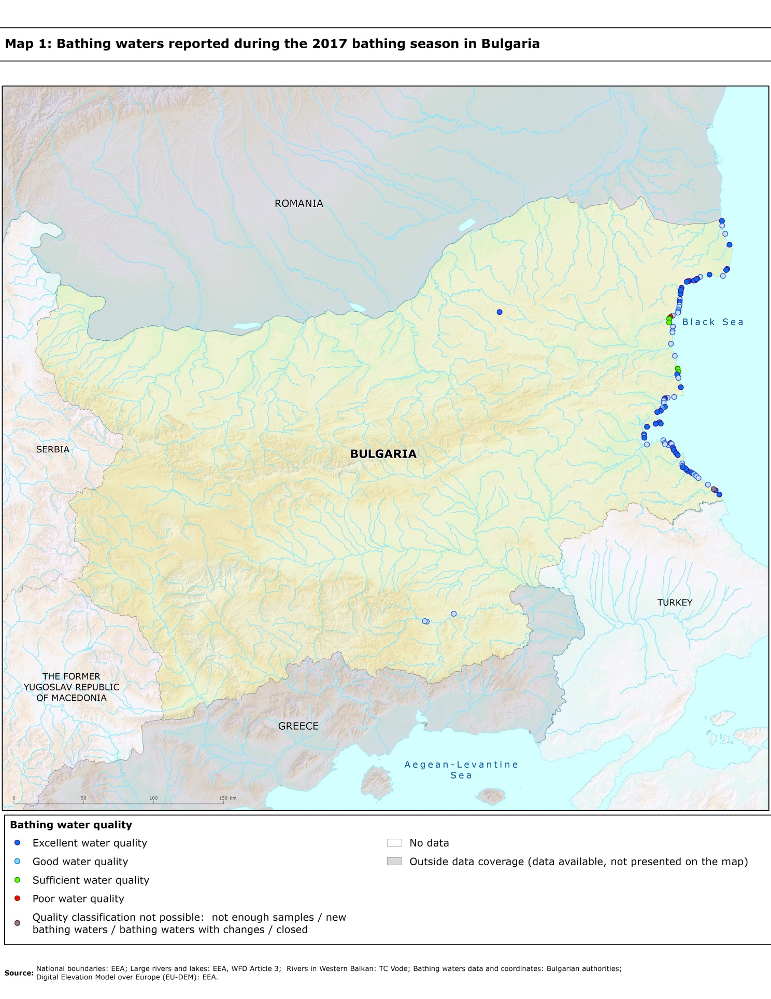

Directive BWD 2006/7/EC, available at http://eur-lex.europa.eu/LexUriServ/LexUriServ.do?uri=OJ:L:2006:064:0037:0051:EN:PDF
See the BWD Data Dictionary for detailed explanations: http://dd.eionet.europa.eu/datasets/3294#tables
The methodology used by the EC and the EEA is described here, while results of assessment by national authorities may differ in individual cases.
A pre-season sample is taken into a sum of samples per season.
Three samples are sufficient if the season does not exceed eight weeks or the region is subject to special geographical constraints.
If, for any reason, it is not possible to take the sample at the scheduled date, a delay of four extra days is allowed. Thus, the interval between two samples should not exceed 31 + 4 days.
Not enough samples have been provided throughout the last assessment period (the last four bathing seasons or, when applicable, the period specified in Article 4.2 or 4.4).
Classification not yet possible because bathing water is newly identified and a complete set of samples is not yet available.
Classification is not yet possible after changes that are likely to affect the classification of the bathing water.
Bathing water is closed temporarily or throughout the bathing season.
http://ec.europa.eu/environment/water/water-bathing/index_en.html
http://www.eea.europa.eu/themes/water/status-and-monitoring/state-of-bathing-water

