BWD Report For the Bathing Season 2017
Belgium

The report gives a general overview of information acquired from the reported data, based on provisions of the Bathing Water Directive. The reporting process is described below, as well as state and trends of bathing water quality in Belgium.

BWD reporting in the season 2017

In the 2017 bathing season, 113 bathing waters have been reported in Belgium. For each bathing water, five groups of parameters have been delivered:
Bathing waters of Belgium in 2017

Total reported 113
Coastal 42
Inland 71

Max season period 138 / 107 days
Coastal 1 Jun to 15 Sep
Inland 1 May to 15 Sep

Samples taken 2127

Share of bathing waters 97 %
with good or excellent
water quality

Reporting under 2010
Directive 2006/7/EC since
- identification data – including name, location, coastal, inland or transitional type of bathing water and availability to bathers;
- seasonal data – including season start and end, national quality classification in the recent season, potential management measures and changes that are likely to affect the classification of the bathing water;
- monitoring results – disaggregated numerical values of two microbiological parameters – intestinal enterococci and Escherichia coli (also known as E. coli), recorded at each water sample taken;
- abnormal situation periods – periods of an event or combination of events impacting on bathing water quality, during which monitoring calendar may be suspended; reporting is optional;
- short-term pollution periods – measurable events of microbiological contamination; reporting is optional.

The authorities of Belgium report data according to the new BWD (2006/7/EC) since the season 2010.

Altogether, 113 bathing waters have been reported – 0.5% of all bathing waters in Europe. One new bathing water has been reported for the recent season. 37% of bathing waters in Belgium are of coastal type; the other 63% are inland. 2127 samples were taken at bathing waters throughout the season – 19 per bathing water on average.

The maximum bathing season period was from 1 June to 15 September for coastal bathing waters, i.e. 107 days altogether. Maximum inland bathing season period was from 1 May to 15 September, i.e. 138 days. Season duration varies for inland bathing waters.

Detailed information on bathing waters is available from national portal at http://aquabact.environnement.wallonie.be/login.do (Wallonia) and http://www.kwaliteitzwemwater.be (Flanders).

Assessment methodology

During the bathing season, water samples are taken and analysed for two bacteria, Escherichia coli and intestinal enterococci which may indicate the presence of pollution, usually originating in sewage, livestock waste, bird faeces etc. The results of the analysis are used to assess the quality of the bathing waters concerned and to provide information to the public on the quality of water in the bathing sites concerned.

The monitoring requirements under the Directive are:
- taking a pre-season sample (taken shortly before the start of the bathing season) ;
- a minimum of four samples per season;
- a minimum of one sample per month.

If these rules are satisfied, the bathing water is categorised as 'sampling frequency satisfied'. If not all monitoring requirements are fulfilled the bathing water is categorised as 'not enough samples'. 99.1% of bathing waters met the described monitoring requirements set by the Directive, while the rest did not satisfy monitoring requirements for different reasons: being new; having changed environmental conditions that might affect water quality classification; closed; not monitored due to legal issues, physical inaccessibility to the site etc. Table 1 shows the statistics of bathing waters according to monitoring requirements.

Table 1: Bathing waters in 2017 according to compliance with BWD monitoring provisions
 | Count | Share of total [%]
BWs with sampling frequency satisfied (and are not new, are not subject to changes or were not closed in 2017)  These bathing waters have been monitored according to provisions and have complete dataset from the last assessment period. They have been quality-classified (excellent, good, sufficient, poor). | 112 | 99.1%
BWs with sampling frequency not satisfied (and are not new, are not subject to changes or were not closed in 2017)  These bathing waters exist throughout the last assessment period but have not been monitored throughout the period according to provisions for various individual reasons. They may be quality-classified if there is an adequate volume of samples available for credible classification. | 1 | 0.9%
BWs that are new, subject to changes or closed in 2017  These bathing waters do not have complete dataset for the last assessment period because they are new, have been subject to changes (that are likely to affect the classification of the bathing water) or have been closed. They cannot be quality-classified. | 0 | 0.0%
Total number of bathing waters in 2017 | 113 | 100%

Bathing waters where sampling frequency was not satisfied can still be quality assessed if at least four samples per season (three samples if the season does not exceed eight weeks or the region is subject to special geographical constraints) are available and equally distributed throughout the season. Assessment of bathing water quality is possible when the bathing water sample dataset is available for four consecutive seasons. Bathing waters are accordingly classified to one of the bathing water quality classes (excellent, good, sufficient, or poor).

The classification is based on pre-defined percentile values for microbiological enumerations, limiting the classes given in Annex I of the Directive. The Directive defines different limit values for coastal and inland waters.

Quality assessment is not possible for all bathing waters. In these cases, they are instead classified as either:
• not enough samples;
• new;
• changes;
• closed.

Bathing water quality

The results of the bathing water quality in Belgium throughout the past period are presented in Figure 1 (for coastal bathing waters) and Figure 2 (for inland bathing waters). The previous reports are available on the European Commission's bathing water quality website and the European Environment Agency's bathing water website.

Coastal bathing waters

In Belgium, all existing coastal bathing waters met at least sufficient water quality standards in 2017. See Appendix 1 for numeric data.

Figure 1: Coastal bathing water quality trend in Belgium. Note: the “At least sufficient” class also includes bathing waters of “Excellent” quality class, the sum of shares is therefore not 100%.

Inland bathing waters

98.6% of all existing inland bathing waters were of at least sufficient water quality in 2017. See Appendix 1 for numeric data.

Figure 2: Inland bathing water quality trend in Belgium. Note: the “At least sufficient” class also includes bathing waters of “Excellent” quality class, the sum of shares is therefore not 100%.

Information regarding management and other issues

Flanders

In Flanders the current bathing water quality is displayed on the website www.kwaliteitzwemwater.be where the latest results can be seen during the season (this website will be renewed in 2018). Each bathing water has a detail page and the bathing water profile where the information on bathing water quality for the past four years is available. Boards with bathing water quality information are placed at bathing waters. In case of problems with the bathing water quality, the necessary measures are taken on the basis of a decision tree. These range from taking extra samples to placing special signs (a visually clear system of smileys) by the rescuers on site. This image system includes four different stages (types of smileys) with meanings: ‘no problem’; ‘discouraged swimming for small children, the elderly and people with a decreased resistance’; ‘the exceedance must still be confirmed by a control sample - until the result is known, swimming is not advised for small children, the elderly and people with a decreased resistance’ and ‘swimming prohibition’.

Most of inland sites in Flanders have no connection to the surface waters, therefore they are only fed by groundwater and rainwater. There are no direct discharges on the Belgian coast in Flanders. Nevertheless, after heavy rainfall, overflows can enter the harbour channels of Nieuwpoort, Oostende, Blankenberge and Zeebrugge together with untreated sewage and thus affect bathing water quality. Modelling study to assess impacts of such overflows and contamination spread was brought into force. Actions intended to minimize the overflow times are proposed on this basis and consultation with various stakeholders (municipalities, sewage infrastructure companies etc.). Projects with aim to reduce the critical overflows are being carried out. Despite the fact that quality of coastal waters have improved, further research is needed since it is still not known how pollution spreads along the coast.

The Walloon region

The official list of bathing waters of Walloon region was submitted to the EC before the start of the 2017 bathing season. The website dedicated to bathing waters (http://aquabact.environnement.wallonie.be) is updated weekly during the bathing season. It provides the results of the bacteriological analyses for the authorized zones and is regularly consulted by the population, the camping managers and environmental managers. The home page presents complete information, with direct links to a map showing the latest analysis results. It supports 3 national languages ​​and English. In 2018, the website is planned to be modified extensively: responsive web design, dynamic map, European symbols (classification, prohibition), more complete, user-friendly and intuitive display, etc.

Based on the results of bacteriological tests and cyanobacteria, a temporary bathing ban can be imposed. The website is up-to-date and clearly indicates which bathing waters are affected by a temporary ban. In the case of a temporary ban, the ban on bathing is immediately communicated to the municipalities concerned. The municipalities must display the ban and install a sign in the immediate vicinity of the bathing water concerned.

Four bathing waters have been excluded from the monitoring programme in season 2016 because they were recognized as unattractive, not visited by a large number of bathers or did not offer enough opportunities for further development.

The programme of actions

In 2016, the Walloon region established a specific program of actions based on the identification of a set of measures specific to the sanitation, agricultural and tourism sector. Implementation of the identified measures should improve the quality of bathing water on a sustainable basis. The action programme started in autumn 2016 and will be subject to periodic evaluation. Given in numbers, 87% of the programme's actions concern sanitation and 13% for other sectors (agriculture, tourism).

In regards to sanitation, treatment program for discharges collective and autonomous zone to improve and maintain the bacteriological quality of bathing water has been implemented in Walloon region. Between 2000 and 2009 a total of € 49 million was provided. The programme running between 2010 and 2014 included an additional € 13 million. The program was extended to 2015-2016, with various priority actions to be carried out on non-compliant bathing water for a budget of € 9 million. Three new sewage treatment plants, built in the catchments of bathing waters Trois-Ponts, Rendeux and Chiny started to operate before the 2016 bathing season. Other projects, among them the construction of 5 treatment plants, are in progress.
Wastewater treatment facilities are implemented on almost all camping sites situated upstream of bathing waters. A decree allowing each farmer to get a grant to cover part of the costs associated with the installation of fences and water troughs has also been adopted by Walloon government.

Public participation

The regional regulations provide the possibility for any person to address observations concerning the revision of the list of bathing waters and the management of the quality of the bathing waters at the Public Service of Wallonia (DGARNE, Department of Environment and Water). The Administration takes into account the relevant comments received in the drafting of its annual report, which the Government takes into account in the development of its policy on bathing water quality management.

Cyanobacteria

The proliferation of cyanobacteria affects some bathing waters in closed environments.

The Region is monitoring the cyanobacteria and eutrophication of water bodies, by visual observations but also laboratory identifications, as well as quantifications of chlorophyll-a and toxins produced by cyanobacteria (microcystins).

In 2017, the administration focused on the most problematic bathing water (BE7200005000000I04). An inventory of the watershed and the lake is in progress, through the implementation of monthly sampling campaigns in one year (April 2017 to April 2018). Samples and analyses concern the characterization of cyanobacteria as well as physico-chemical parameters related to the eutrophication of the water body (nitrogen, phosphorus).

The data collected should be able to characterize the input of nutrients entering the lake and the content stored in the sediments. Concrete recovery actions could be released once the inventory has been completed. It is very likely that a complete emptying of the lake with cleaning is necessary.

In addition, other actions were carried out this summer or are scheduled such as the control of farms, campsites or parks adjacent to the lake, etc. to better understand where the nutrients come from and how to fix them.

During the summer of 2017, about fifteen tourist accommodations were checked by the administration to verify the sanitation facilities in place, the actual connections to the collective network, and where appropriate the effectiveness of disinfection treatments.

The Directive allows the suspension of the monitoring schedule in abnormal situations (Article 3.7). For bathing water BE6400002000000H19, there was a particular event that occurred upstream. Indeed, during road works with renewal of sewage made in the city centre, construction site accidents led to a release in the receiving environment. Investigations were conducted; bathing was banned on 9 July 2017. No malfunction of storm overflows and pumping stations during dry weather was detected during weekly checks. Other investigations are planned in connection with the Bathing Action Program. Until a return to normal, swimming should be banned in 2018.

Bathing water quality assessment presentation in online viewers

The European bathing water legislation focuses on sound management of bathing waters, greater public participation and improved information dissemination. More on the bathing and other water legislation can be found on the European Commission's website: http://ec.europa.eu/environment/water/index_en.htm.

The bathing water section of the Water Information System for Europe (WISE) which is accessible at the EEA bathing water website (http://www.eea.europa.eu/themes/water/interactive/bathing/state-of-bathing-waters) allows users to view the bathing water quality at more than 21 000 coastal and inland sites across Europe. The WISE bathing water quality data viewer combines text and graphical visualisation, providing a quick overview of the bathing water's locations and achieved quality. Having access to bathing water information, citizens are encouraged to make full use of it and participate with their comments.

Appendix 1: Results of bathing water quality in Belgium from 2014 to 2017

Table 2: Bathing waters in the season 2017 according to quality
 |  | Total  number  of  bathing  waters | Excellent quality |  | At least  sufficient  quality |  | Poor quality |  | Quality  classification  not possible: not  enough samples  /new bathing  waters/bathing  waters subject to changes/closed
 |  | Total  number  of  bathing  waters | Count | % | Count | % | Count | % | Count | %
Coastal | 2014 | 42 | 29 | 69.0 | 42 | 100.0 | 0 | 0.0 | 0 | 0.0
Coastal | 2015 | 42 | 32 | 76.2 | 42 | 100.0 | 0 | 0.0 | 0 | 0.0
Coastal | 2016 | 42 | 38 | 90.5 | 42 | 100.0 | 0 | 0.0 | 0 | 0.0
Coastal | 2017 | 42 | 40 | 95.2 | 42 | 100.0 | 0 | 0.0 | 0 | 0.0
Inland | 2014 | 68 | 55 | 80.9 | 65 | 95.6 | 2 | 2.9 | 1 | 1.5
Inland | 2015 | 71 | 58 | 81.7 | 68 | 95.8 | 1 | 1.4 | 2 | 2.8
Inland | 2016 | 71 | 58 | 81.7 | 70 | 98.6 | 1 | 1.4 | 0 | 0.0
Inland | 2017 | 71 | 57 | 80.3 | 70 | 98.6 | 1 | 1.4 | 0 | 0.0
Total | 2014 | 110 | 84 | 76.4 | 107 | 97.3 | 2 | 1.8 | 1 | 0.9
Total | 2015 | 113 | 90 | 79.6 | 110 | 97.3 | 1 | 0.9 | 2 | 1.8
Total | 2016 | 113 | 96 | 85.0 | 112 | 99.1 | 1 | 0.9 | 0 | 0.0
Total | 2017 | 113 | 97 | 85.8 | 112 | 99.1 | 1 | 0.9 | 0 | 0.0
Note: the class “At least sufficient” also includes bathing waters which are of excellent quality, the sum of shares is therefore not 100%.

Appendix 2: Bathing water quality map

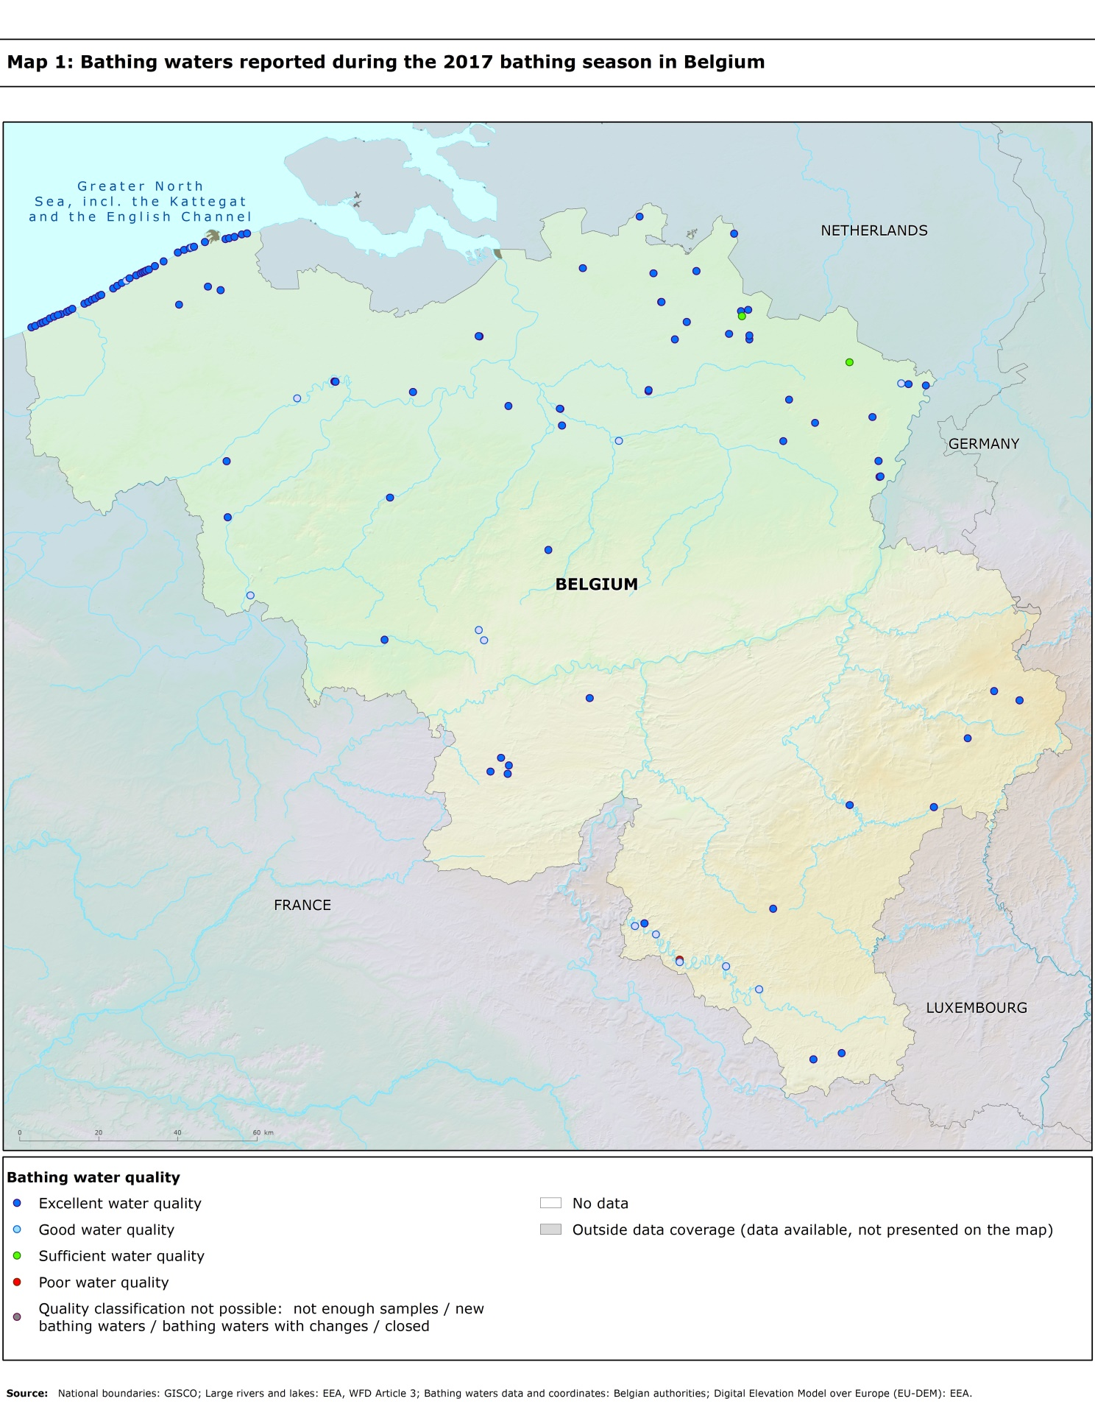

Directive BWD 2006/7/EC, available at http://eur-lex.europa.eu/LexUriServ/LexUriServ.do?uri=OJ:L:2006:064:0037:0051:EN:PDF
See the BWD Data Dictionary for detailed explanations: http://dd.eionet.europa.eu/datasets/3294#tables
The methodology used by the EC and the EEA is described here, while results of assessment by national authorities may differ in individual cases.
A pre-season sample is taken into a sum of samples per season.
Three samples are sufficient if the season does not exceed eight weeks or the region is subject to special geographical constraints.
If, for any reason, it is not possible to take the sample at the scheduled date, a delay of four extra days is allowed. Thus, the interval between two samples should not exceed 31 + 4 days.
Not enough samples have been provided throughout the last assessment period (the last four bathing seasons or, when applicable, the period specified in Article 4.2 or 4.4).
Classification not yet possible because bathing water is newly identified and a complete set of samples is not yet available.
Classification is not yet possible after changes that are likely to affect the classification of the bathing water.
Bathing water is closed temporarily or throughout the bathing season.
http://ec.europa.eu/environment/water/water-bathing/index_en.html
http://www.eea.europa.eu/themes/water/status-and-monitoring/state-of-bathing-water

